**Impact of the Italian astronomical community on the ground and space observational facilities: 2008-2012**

**A report by**

**the Consiglio Scientifico of INAF**

1. **Introduction**

The aim of this report is to provide some hints on the present use of ground and space observational facilities by the Italian astronomical community. To this purpose, it is presented the Italy/World comparison of the allocated time of each facility and instrument along the years (2008-2012 and 2013 when available) including some information concerning the proposal scientific categories foreseen for the observational time request of each facility. Data on the scientific production – in terms of papers on refereed journals - are also presented for each facility.

The data have been collected with the precious help of M. Perri and G. Perini (ASDC), F. Patat (ESO), E. Molinari (TNG), A. Fontana (LBT), C. Stanghellini (IRA) e P. Schipani (CS). Due to the intrinsic inhomogeneity, the report is arranged to show the data of each single facility in one section. Few comments are provided at this step of presentation, leaving the general comments to the CS and CdA of INAF.

The data available at the moment refers to the following facilities:

***Space:***

* INTEGRAL
* FERMI
* XMM
* AGILE
* SWIFT
* HERSCHEL
* HST
* CHANDRA

***Ground:***

* ESO (VLT, VLTI, NTT, VISTA, 3.6m, 2.2m, 1.5m, ALMA, APEX)
* TNG
* LBT
* Medicina and Noto Radiotelescopes

The databases

The data used for this report are typically collected from public databases with specific queries. In particular, the specific sources of information concerning space facilities are reported at the beginning of the dedicated section. In the case of the ESO facilities the data on the allocated time to Italian P.I.s have been requested to the Observing Programmes Office of ESO, while the data concerning publications originate from specific queries to the Telescope Bibliography maintained by the ESO library (<http://telbib.eso.org/>). E. Molinari and A. Fontana have kindly provided TNG and LBT data.

The papers have been separated in to two samples (Italy/World) according to the affiliation of the first author. The Italian affiliations include INAF and Italian Universities (so that a large number of researchers associated to INAF are also included). Authors affiliated to INFN are also included but they have statistical relevance mainly for the FERMI mission (papers with first author by INAF and INFN have been separated).

Papers are related to each mission by explicit citation in the abstract of the papers of the name of the mission. This method has been checked to be in good agreement (within 5%) with other works that make use of more detailed search and analysis methods.

Rome, June 2014

1. **Space Facilities**

# Space facility 1 : INTEGRAL

***INTE****rnational* ***G****amma-****R****ay* ***A****strophysics* ***L****aboratory*

Launch: 2002

The mission is dedicated to the fine spectroscopy (E/∆E = 500) and fine imaging (angular resolution: 12 arcmin FWHM) of celestial gamma-ray sources in the energy range 15 keV to 10 MeV with concurrent source monitoring in the X-ray (4-35 keV) and optical (V-band, 550 nm) energy ranges.

Status: ongoing

#### 1) ACCEPTED OBSERVING PROPOSALS (2008-2013):

Origin of data:

* "INTEGRALAO" DATABASE (HEASARC-NASA)

(http://heasarc.gsfc.nasa.gov/W3Browse/all/integralao.html)

|  |  |
| --- | --- |
| Categories: |  |
|  | Core Proposal |
|  | Extragalactic Astronomy |
|  | Galactic Astronomy |
|  | Nucleosynthesis and diffuse emission |
|  | Others |

The following tables and figures show the data on the allocated observing time (ks).

|  |  |  |  |  |  |  |  |  |  |  |  |  |  |  |
| --- | --- | --- | --- | --- | --- | --- | --- | --- | --- | --- | --- | --- | --- | --- |
| **World** | | | Year | |  |  | |  | |  | |  | |  |
| Category | 2008 | 2009 | | 2010 | | | 2011 | | 2012 | | 2013 | | Tot.cat. | |
| Core Proposal | | | 4332.2 | | 1800.0 |  | |  | |  | |  | | 6132.2 |
| Extragalactic Astronomy | | | 3051.9 | | 4954.1 | 7632.9 | | 5615.6 | | 3988.7 | | 1898.7 | | 27141.9 |
| Galactic Astronomy | | | 3592.4 | | 3237.7 | 8535.1 | | 5721.3 | | 10040.2 | | 1544.3 | | 32671.1 |
| Nucleosynthesis and diffuse emission | | | 4383.1 | | 0.0 | 7008.2 | | 8372.5 | | 8805.8 | | 3166.0 | | 31735.5 |
| Others | | | 9028.9 | | 15387.6 | 7642.9 | | 5954.4 | |  | |  | | 38013.9 |
| **Grand total** | | | **24388.4** | | **25379.4** | **30819.1** | | **25663.9** | | **22834.7** | | **6609.1** | | **135694.5** |
|  | | |  | |  |  | |  | |  | |  | |  |
| **Italy** | | | Year | |  |  | |  | |  | |  | |  |
| Category | | | 2008 | | 2009 | 2010 | | 2011 | | 2012 | | 2013 | | Tot. cat. |
| Core Proposal | | |  | |  |  | |  | |  | |  | | 0.0 |
| Extragalactic Astronomy | | | 503.3 | | 1700.3 | 1031.1 | | 0.0 | | 0.0 | | 396.5 | | 3631.2 |
| Galactic Astronomy | | | 0.0 | | 0.0 | 0.0 | | 1827.8 | | 4942.9 | | 239.8 | | 7010.5 |
| Nucleosynthesis and diffuse  emission | | | | |  |  | |  | |  | |  | | 0.0 |
| Others | | | 0.0 | | 2000.4 | 1590.0 | |  | |  | |  | | 3590.4 |
| **Grand total** | | | **503.3** | | **3700.7** | **2621.1** | | **1827.8** | | **4942.9** | | **636.3** | | **14232.1** |
|  | | |  | |  |  | |  | |  | |  | |  |
|  | | |  | |  |  | |  | |  | |  | |  |
|  | | |  | |  |  | |  | |  | |  | |  |
| **Italy vs. World** | | |  | |  |  | |  | |  | |  | |  |
| Category | | | 2008 | | 2009 | 2010 | | 2011 | | 2012 | | 2013 | | Italian tot. observed cat. |
| Core Proposal | | | 0% | | 0% | 0% | | 0% | | 0% | | 0% | | 0.0% |
| Extragalactic Astronomy | | | 16% | | 34% | 14% | | 0% | | 0% | | 21% | | 13.4% |
| Galactic Astronomy | | | 0% | | 0% | 0% | | 32% | | 49% | | 16% | | 21.5% |
| Nucleosynthesis and diffuse emission | | | 0% | | 0% | 0% | | 0% | | 0% | | 0% | | 0.0% |
| Others | | | 0% | | 13% | 21% | | 0% | | 0% | | 0% | | 9.4% |
| **Italian year observed cat.** | | | **2.1%** | | **14.6%** | **8.5%** | | **7.1%** | | **21.6%** | | **9.6%** | | **10.5%** |

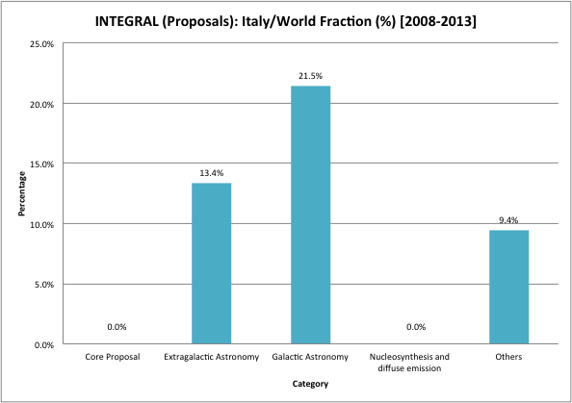

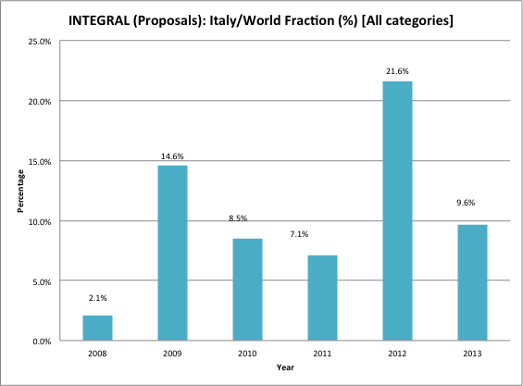

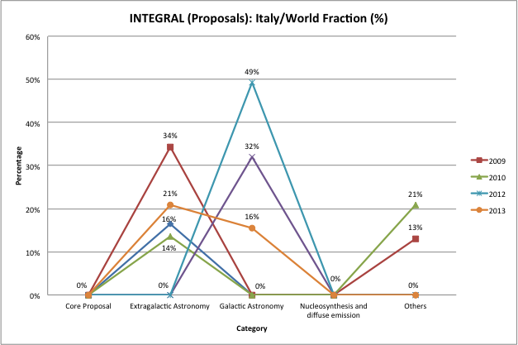

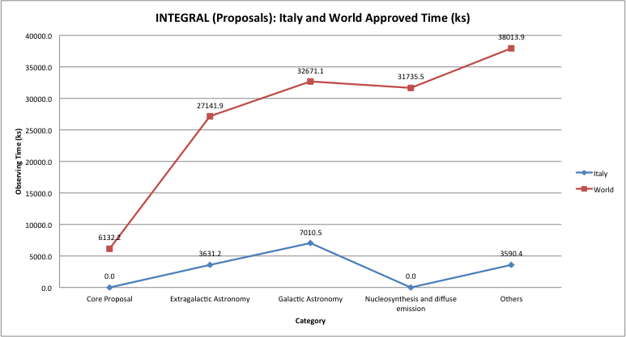

#### 2) REFEREED PAPERS (2008-2013):

Origin of data:

* SAO/NASA Astrophysics Data System (ADS)

(query: "INTEGRAL" string in the abstract)

|  |  |  |  |  |  |  |  |
| --- | --- | --- | --- | --- | --- | --- | --- |
|  |  |  |  |  |  |  |  |
|  |  |  |  |  |  |  |  |
|  | 2008 | 2009 | 2010 | 2011 | 2012 | 2013 | Grand total |
| World | 115 | 122 | 105 | 82 | 73 | 17 | 514 |
| Italy | 27 | 28 | 19 | 26 | 14 | 2 | 116 |
| Rest of the World | 88 | 94 | 86 | 56 | 59 | 15 | 398 |
| Italy vs. World | 23% | 23% | 18% | 32% | 19% | 12% | 23% |

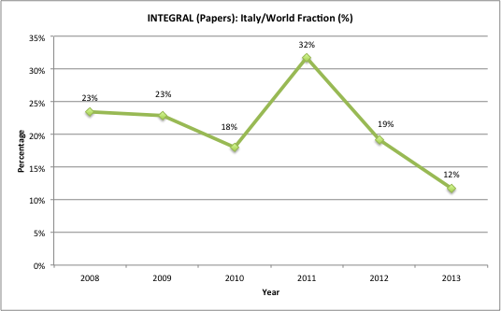

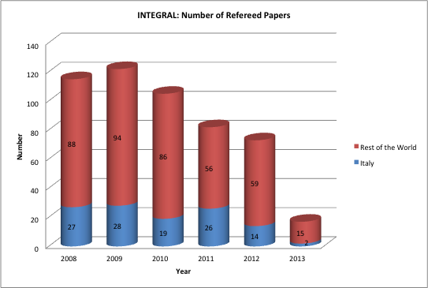

# Space facility 2 : FERMI

***Fermi Gamma-ray Space Telescope***

Launch: 2008

Fermi has an imaging gamma-ray telescope vastly more capable than instruments flown previously, as well as a secondary instrument to augment the study of gamma-ray bursts. The main instrument, the [Large Area Telescope](http://fermi.gsfc.nasa.gov/science/instruments/lat.html) (LAT), has superior area, angular resolution, field of view, and deadtime that together provide a factor of 30 or more advance in sensitivity, as well as capability for studying of transient phenomena (http://fermi.gsfc.nasa.gov/science/instruments/table1-1.html). The [Gamma-ray Burst Monitor](http://fermi.gsfc.nasa.gov/science/instruments/gbm.html) (GBM) has a field of view several times larger than LAT and provides spectral coverage of gamma-ray bursts that extends from the lower limit of LAT down to 10 keV.

Status: ongoing

The specific policy of this mission prevents statistics on the proposals. The data of the continuous survey of the sky are public and ready in the archive facility. Thus, the observations are immediately available to the astronomical community without any time requests. We acknowledge D. Gasparrini and S. Cutini (ASDC) for their help in the generation of the tables.

#### 2) REFEREED PAPERS FROM MEMBERS OF THE LAT COLLABORATION (2008-2013):

Origin of data:

* Fermi LAT collaboration

(https://www-glast.stanford.edu/cgi-bin/pubpub)

|  |  |
| --- | --- |
| Categories: |  |
|  | AGN |
|  | Calibration |
|  | Catalogs |
|  | Dark matter |
|  | Diffuse |
|  | Galactic |
|  | GRBs |
|  | Solar |
|  | General |

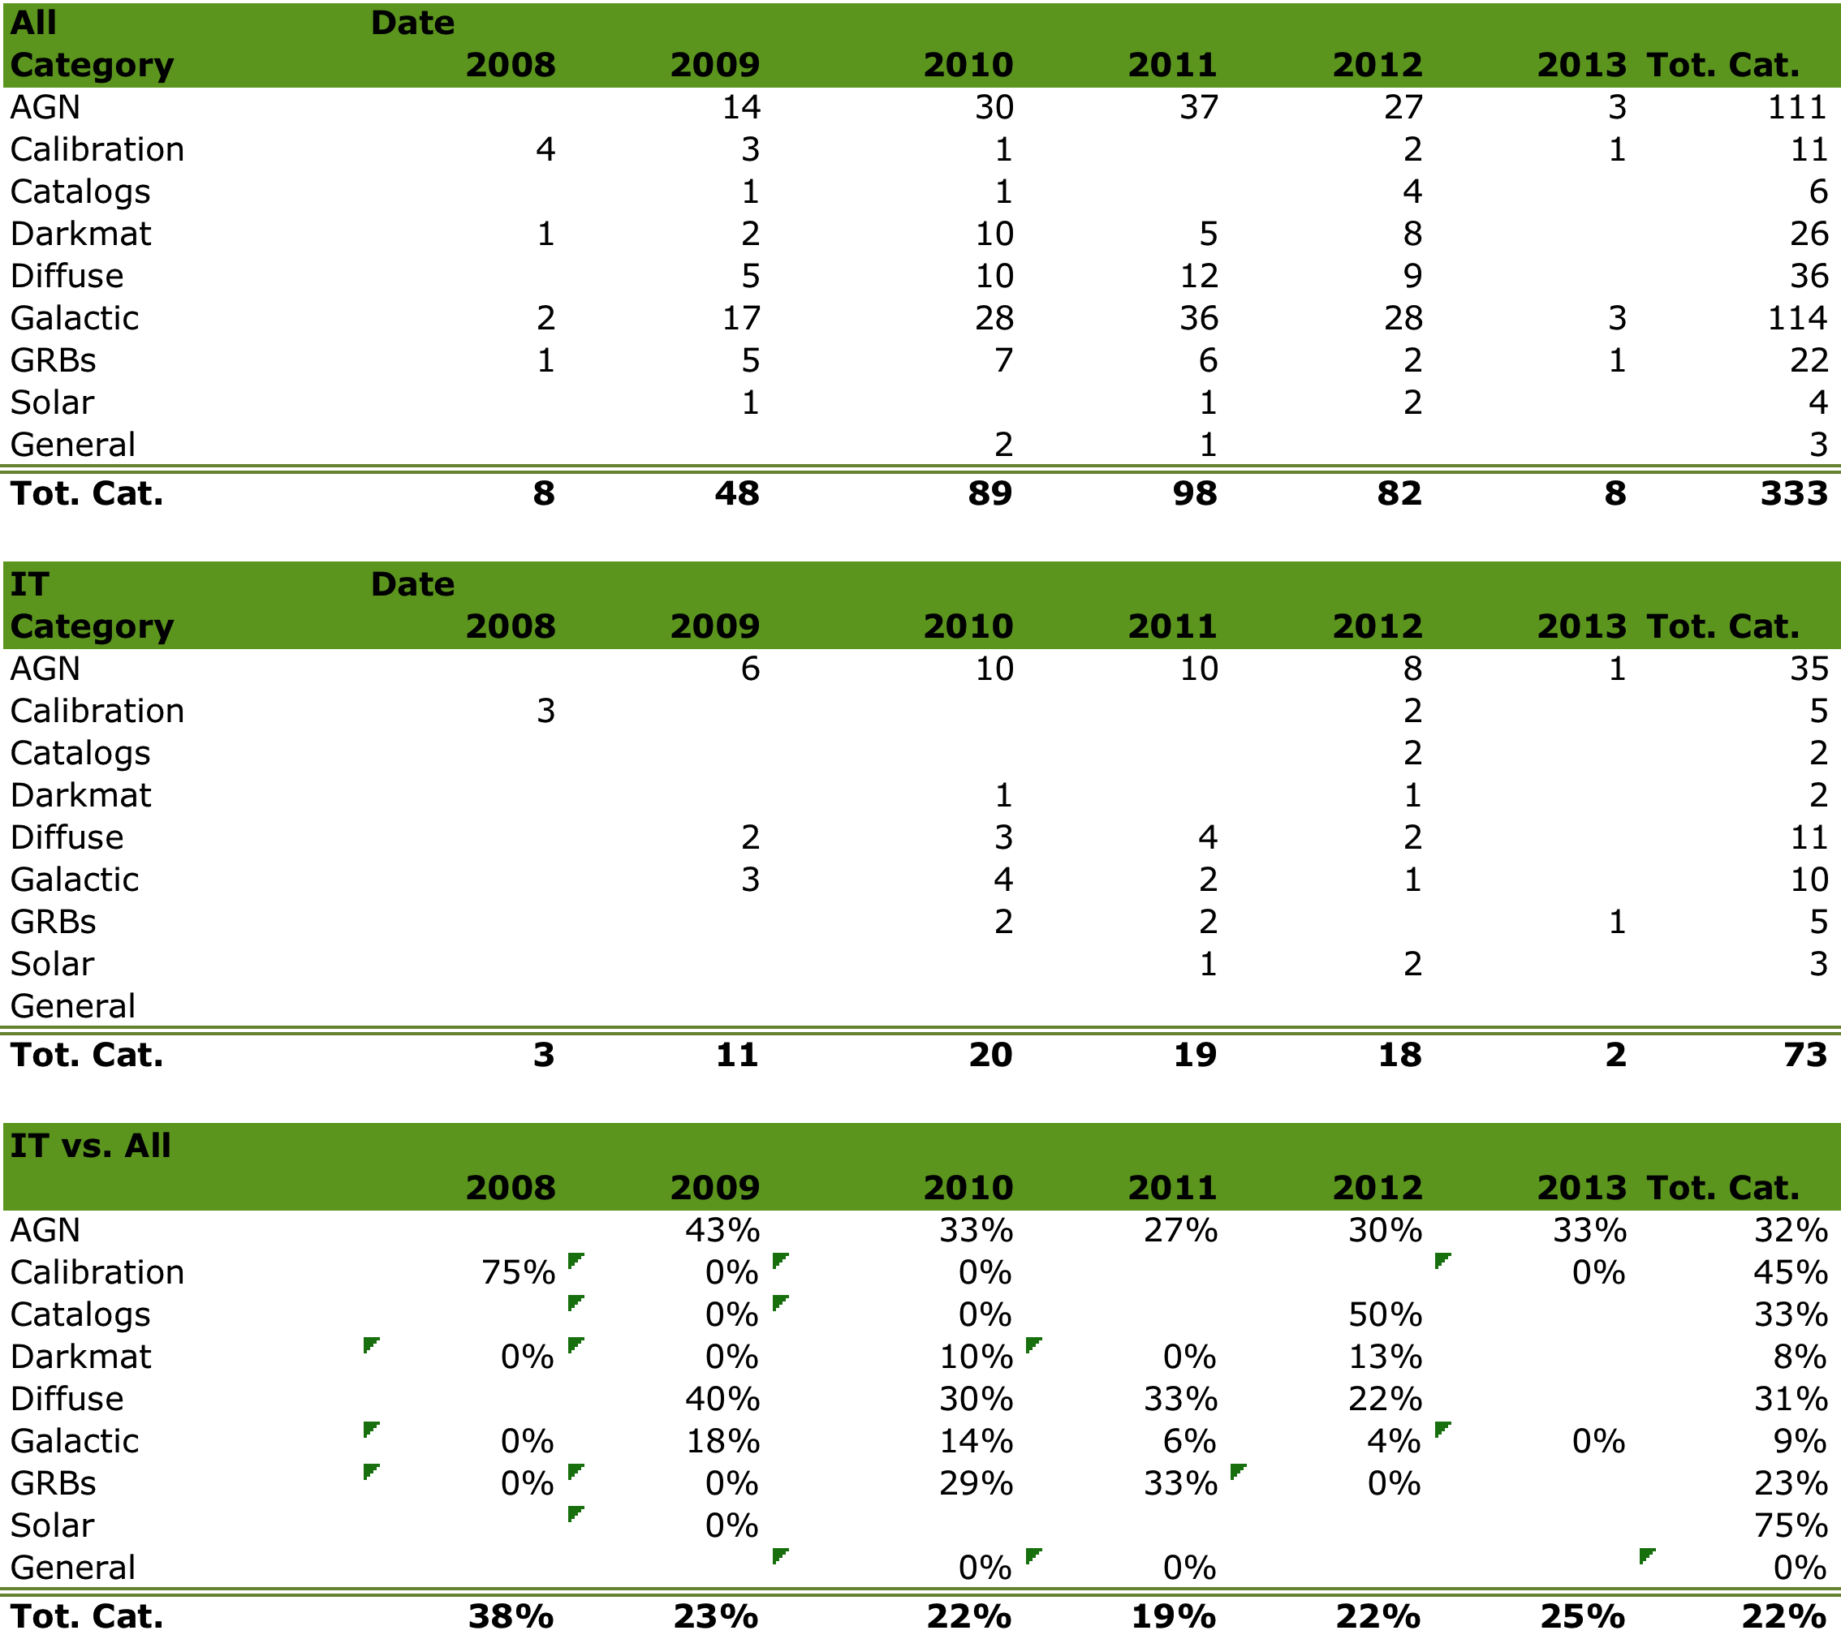

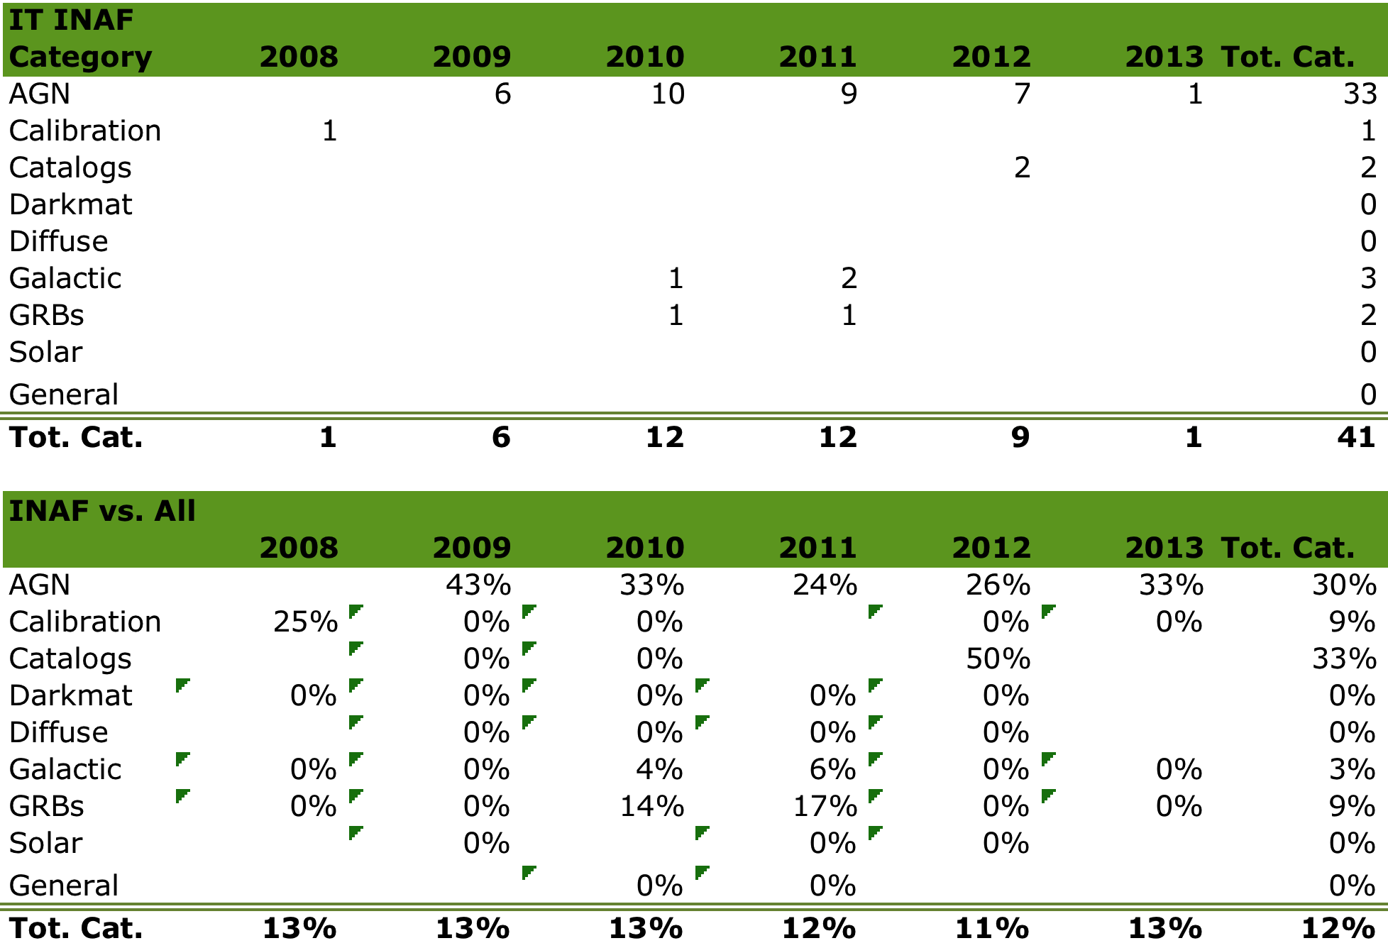

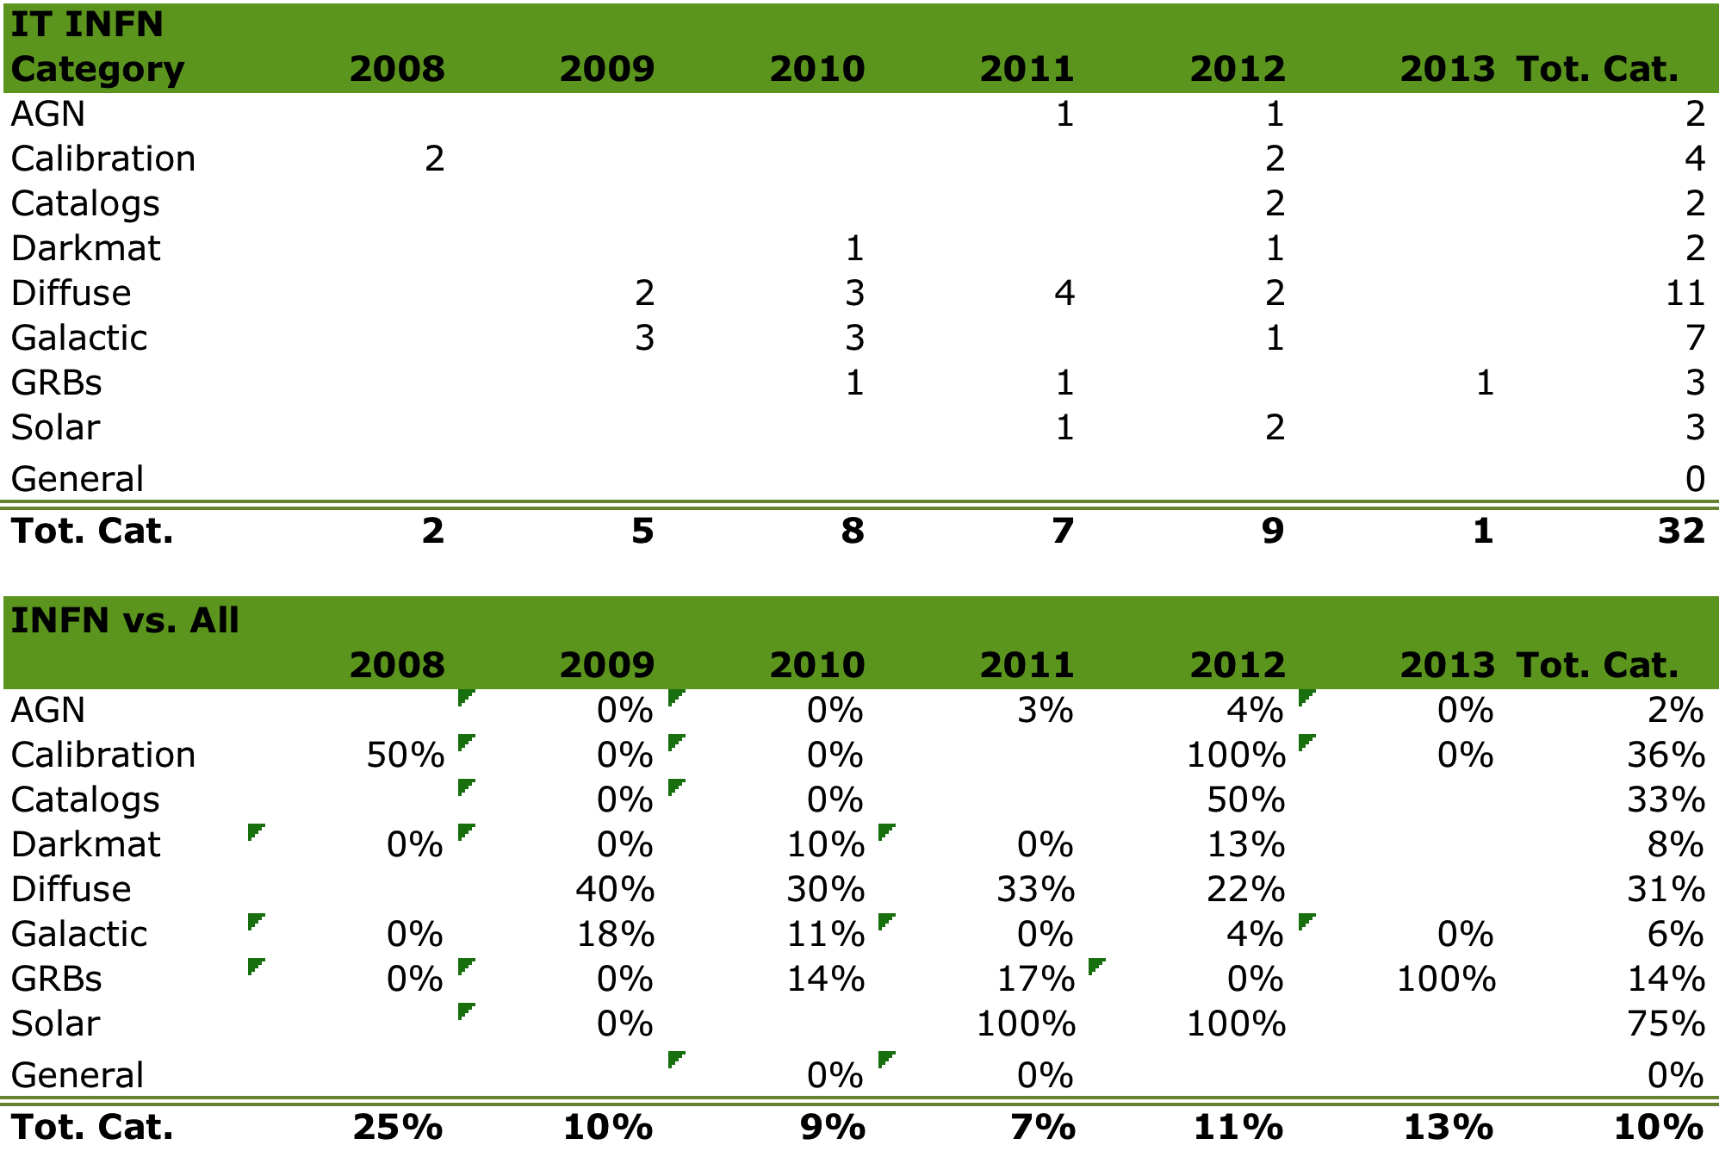

Global statistics for INAF and INFN:

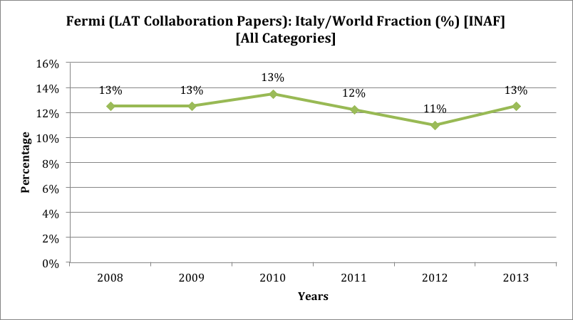

#### 2bis) REFEREED PAPERS OUT OF THE LAT COLLABORATION (2008-2013):

Origin of data:

* SAO/NASA Astrophysics Data System (ADS)

(query: "FERMI LAT" string in the abstract)

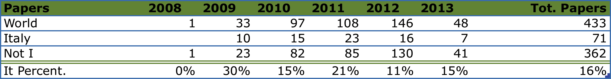

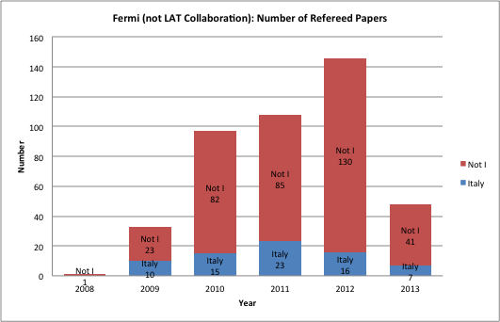

# Space facility 3 : XMM-NEWTON

***X-ray Multi-Mirror–NEWTON Space Telescope***

Launch: 1999

XMM-Newton high quality focusing mirrors and battery of instruments enable it to investigate spectra of cosmic X-ray sources with a limiting flux of 10-15 erg cm-2 s-1; to perform sensitive medium-resolution spectroscopy with resolving powers between 150 and 800 over the wavelength band 5 - 35 Å (350 - 2500 eV); to provide broad band imaging spectroscopy from 150 eV to 15 keV (0.8 - 80 Å) and to obtain simultaneous sensitive coverage of the wavelength band 1700 to 6500 Å through a dedicated co-aligned optical monitor

Status: ongoing

***1) ACCEPTED OBSERVING PROPOSALS (2008-2012):***

Origin of data:

* ESA XMM-Newton Science Operations Centre

(http://xmm.esac.esa.int/external/xmm_news/otac_results/index.shtml)

|  |  |
| --- | --- |
| Categories: |  |
| **A** | Stars, White Dwarfs and Solar System |
| **B** | White Dwarf Binaries, Neutron Star Binaries, Cataclysmic Variables, ULXs and Black Holes |
| **C** | Supernovae, Supernova Remnants, Diffuse (galactic) Emission and Isolated Neutron Stars |
| **D** | Galaxies and Galactic Surveys |
| **E** | Active Galactic Nuclei, Quasars, BL-Lac Objects |
| **F** | Galaxies, Groups of Galaxies, Clusters of Galaxies and Super-clusters |
| **G** | Cosmology, Extragalactic Deep Fields and Large Extragalactic Areas |

The following tables and figures show the data on the allocated observing time (ks).

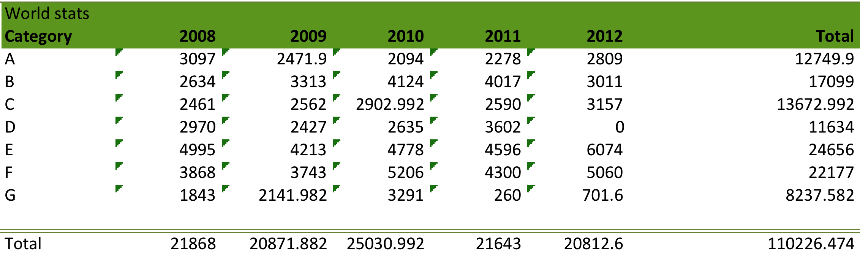

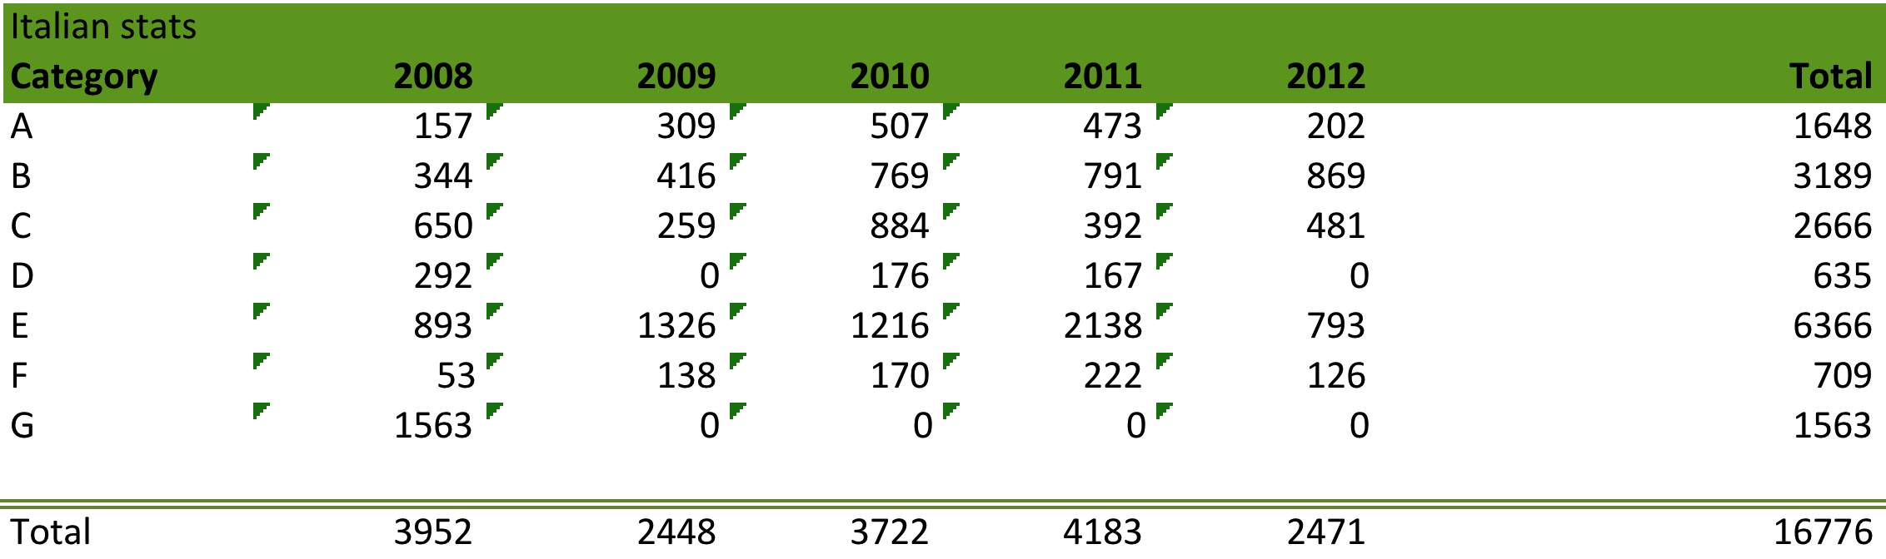

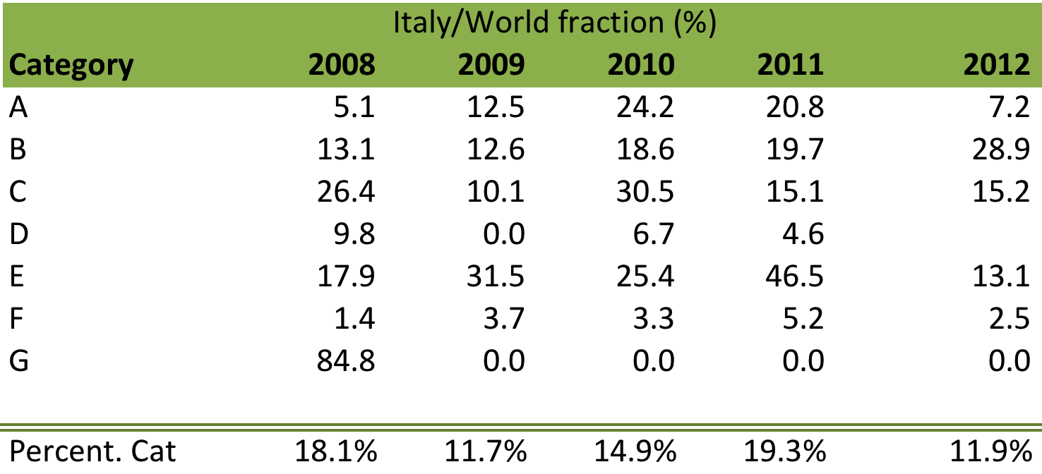

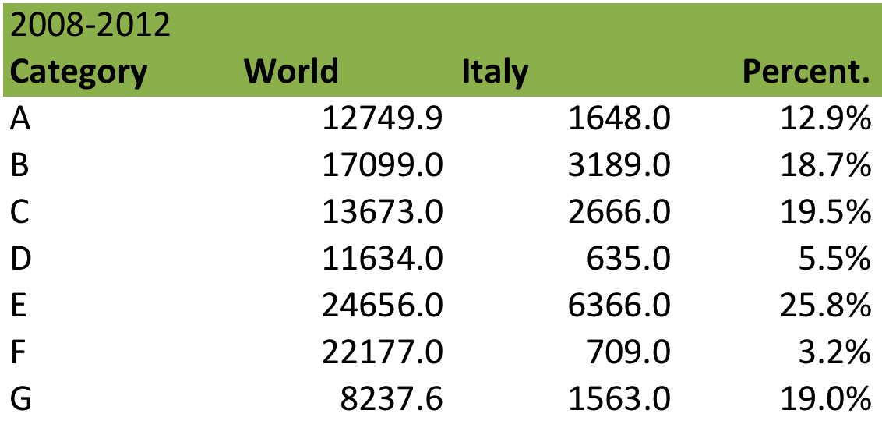

***2) REFEREED PAPERS (2008-2013):***

Origin of data:

* ESA XMM-Newton Science Operations Centre

(http://heasarc.gsfc.nasa.gov/docs/xmm/xmmbib_author.html)

|  |  |  |
| --- | --- | --- |
| Categories: | |  |
|  | 1 | Instrumentation |
|  | 2 | Background/Surveys |
|  | 3 | Galaxy Clusters |
|  | 4 | AGN |
|  | 5 | Galaxies |
|  | 6 | GRBs |
|  | 7 | ISM |
|  | 8 | Stellar Clusters |
|  | 9 | SNRs/SNe |
|  | 10 | Planetary Nebulae |
|  | 11 | X-Ray Binaries |
|  | 12 | Cataclysmic Variables |
|  | 13 | Neutron Stars |
|  | 14 | Stars |
|  | 15 | Solar System |

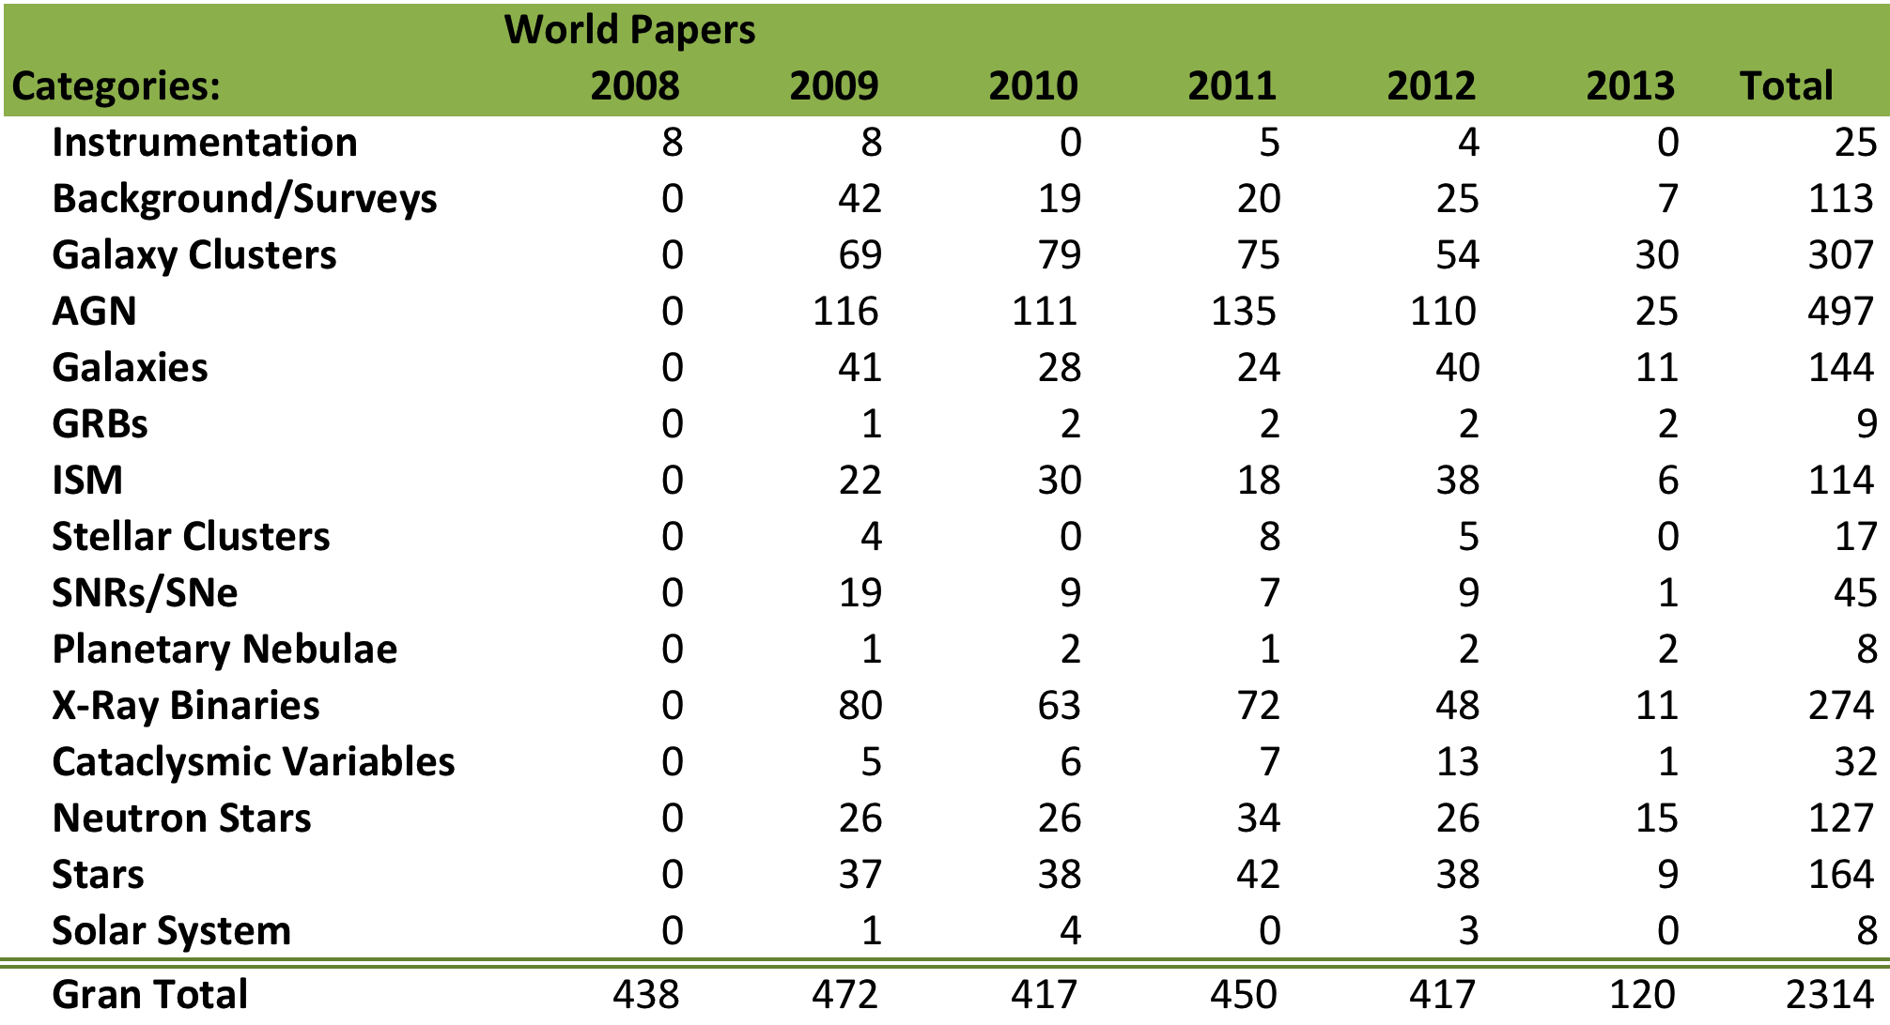

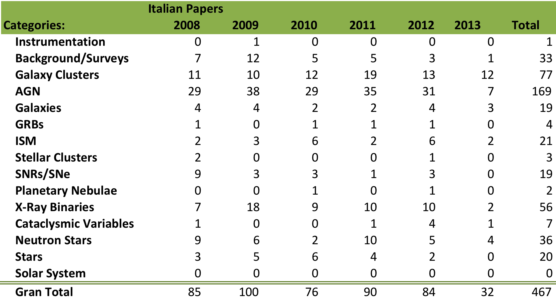

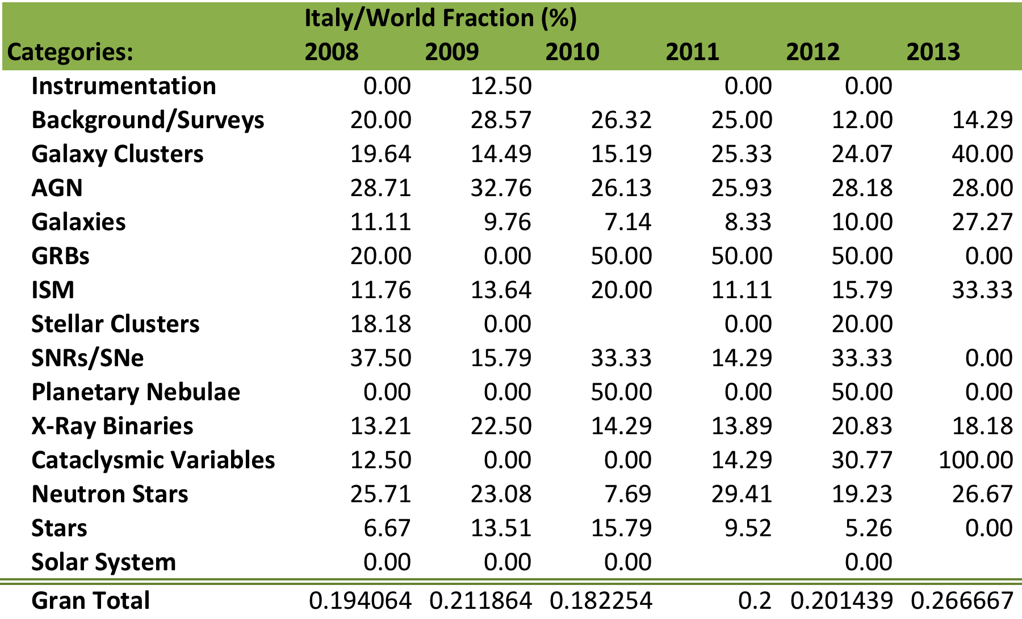

# Space facility 4 : AGILE

***Astrorivelatore Gamma a Immagini LEggero***

Launch: 2007

AGILE is a space mission dedicated to X-ray and gamma astrophysics with imaging capabilities. It is equipped with a gamma-ray detector, sensitive to photons with energy in the range 30 MeV - 50 GeV, and a hard X-ray detector, sensitive in the range 18 - 60 keV. The instrument is completed by a calorimeter (energy range 250 keV - 100 MeV) and by an anti-coincidence system. We acknowledge C. Pittori and G. Fanari (ASDC) for their help in the generation of the proposal tables.

Status: ongoing

***1) ACCEPTED OBSERVING PROPOSALS (2008-2012):***

Origin of data:

* AGILE SCIENCE DATA CENTRE (ASDC)

(http://agile.asdc.asi.it:8080/proposalAO4_view.php)

(http://agile.asdc.asi.it:8080/proposalAO3_view.php)

(http://agile.asdc.asi.it:8080/proposalAO2_view.php)

(http://agile.asdc.asi.it:8080/proposal_view.php)

|  |  |
| --- | --- |
| Categories: |  |
|  | 1AGL Sources (Follow up of the sources included in the first AGILE catalogue) |
|  | 1FGL Sources (Follow up of the sources included in the first FERMI catalogue) |
|  | 3EG Sources (Follow up of the sources included in the EGRET catalogue) |
|  | Active Galactic Nuclei |
|  | Pulsars |
|  | Stars |

The following tables and figures show the number of approved proposal.

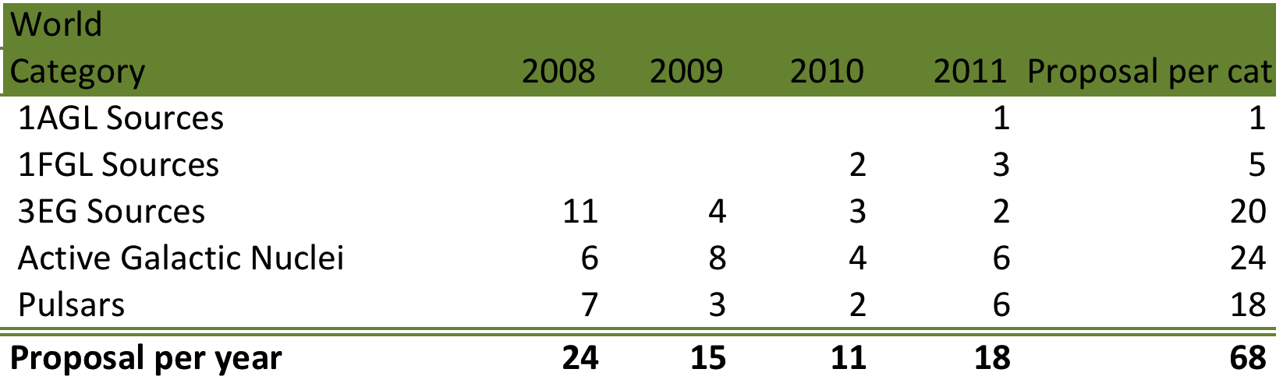

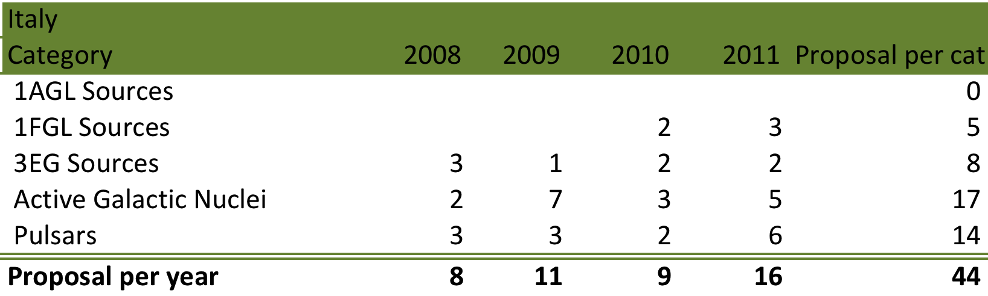

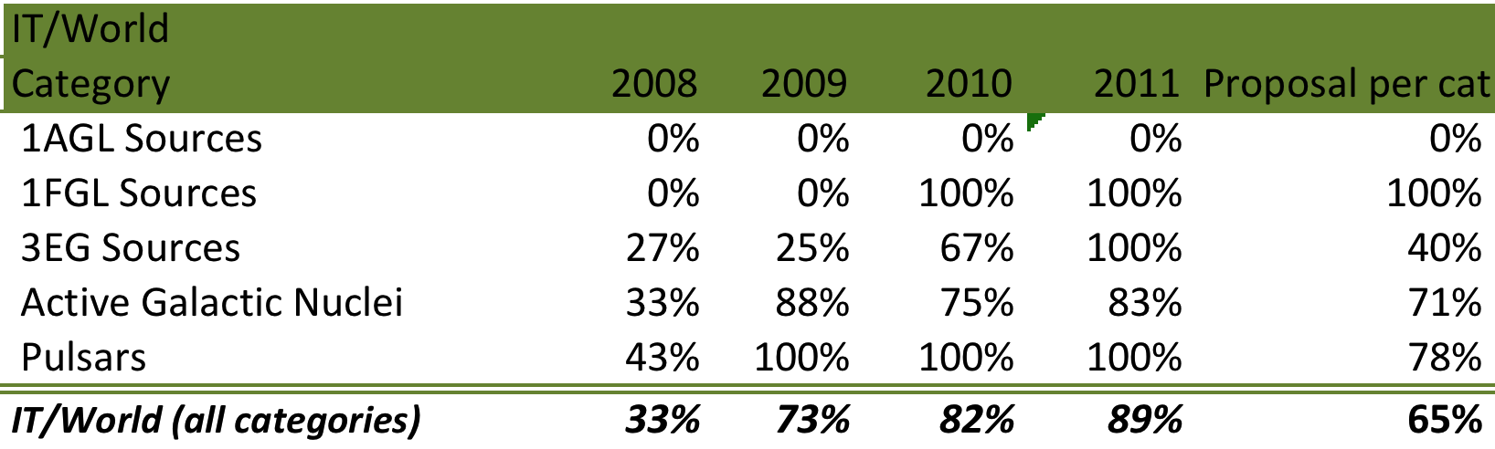

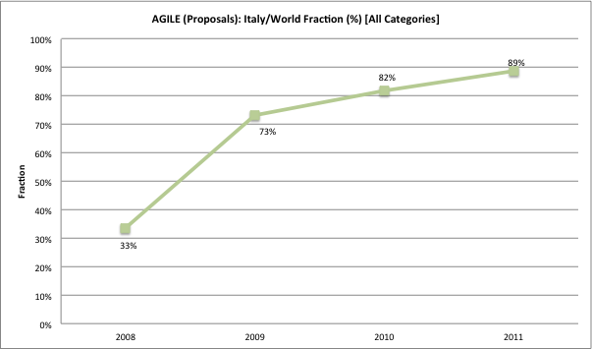

***2) REFEREED PAPERS (2008-2013):***

Origin of data:

* SAO/NASA Astrophysics Data System (ADS)

(query: "AGILE" string in the abstract)

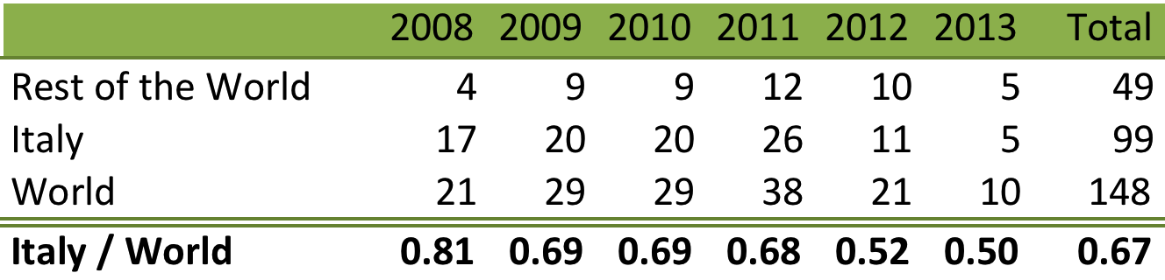

# Space facility 5 : SWIFT

***SWIFT observatory***

Launch: 2007

The Swift telescope payload is comprised of three instruments, which work in tandem to provide rapid identification and multi-wavelength follow-up of gamma-ray bursts (GRBs) and their afterglows. The instruments are: i) the Burst Alert Telescope (BAT) working in the range 15 - 150 keV; ii) the X-ray Telescope (XRT) observing in the range 0.3 - 10 keV and the UV/Optical Telescope (UVOT) to explore the UV (170 - 600 nm).

Status: ongoing

The specific policy of this mission prevents the statistics on the proposals. The data of the continuous survey of the sky are public and ready in the archive facility within few hours. Thus, the observations are immediately available to the astronomical community without any time requests.

***2) REFEREED PAPERS (2008-2013):***

Origin of data:

* SAO/NASA Astrophysics Data System (ADS)

(query: "Swift" string in the abstract)

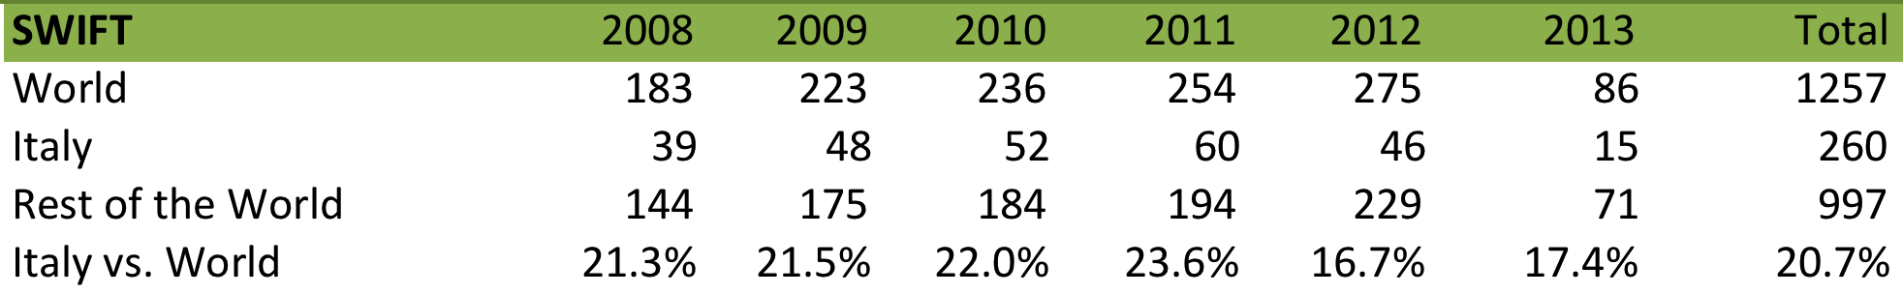

# Space facility 6 : HERSCHEL

***Herschel Space Observatory***

Launch: 2009

The Herschel telescope is a Cassegrain design with a primary mirror diameter of 3.5m. The three scientific instruments are: HIFI (Heterodyne Instrument for the Far Infrared), a very high resolution heterodyne spectrometer; PACS (Photodetector Array Camera and Spectrometer), an imaging photometer and medium resolution grating spectrometer and SPIRE (Spectral and Photometric Imaging Receiver), an imaging photometer and an imaging Fourier transform spectrometer. We acknowledge L. Calzoletti and A. Di Cecco (ASDC) for their help in the generation of the publication and proposal tables.

Status: cryogenic phase concluded on 29 April 2013.

***1) ACCEPTED OBSERVING PROPOSALS (2008-2011):***

Origin of data:

* + - HERSCHEL SCIENCE CENTRE (ESA)

(http://herschel.esac.esa.int/Key_Programmes.shtml)

(http://herschel.esac.esa.int/AO-1_Programmes.shtml)

(<http://herschel.esac.esa.int/AO-2_Programmes.shtml>)

*Note:* Several “Key Project” having non-Italian P.I.s shows a wide contribution of the Italian astronomical community. As a matter of fact, the Italian contribution is particularly relevant for the following categories "Cosmology", "Galaxies/AGNs" e "ISM/Star formation", although the number of Italian PIs is limited. As a consequence, the actual Italian contribution to accepted proposals, evaluated with the present criteria (P.I. nationality), is quite underestimated for these categories.

|  |  |
| --- | --- |
| Categories: |  |
|  | Cosmology |
|  | Galaxies/AGNs |
|  | ISM/Star formation |
|  | Solar System |
|  | Star Formation |
|  | Stars |

The following tables and figures show the data on the allocated observing time (hours).

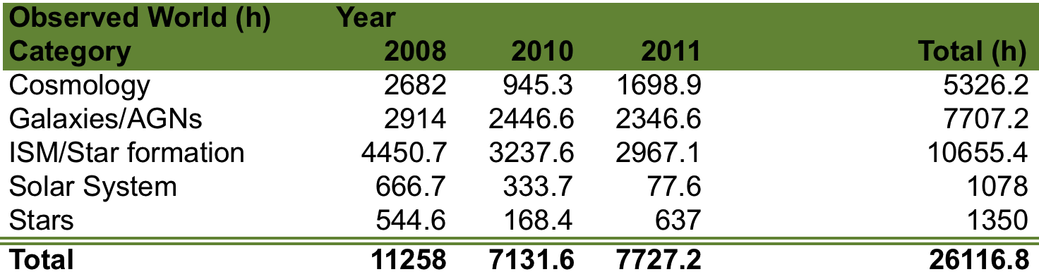

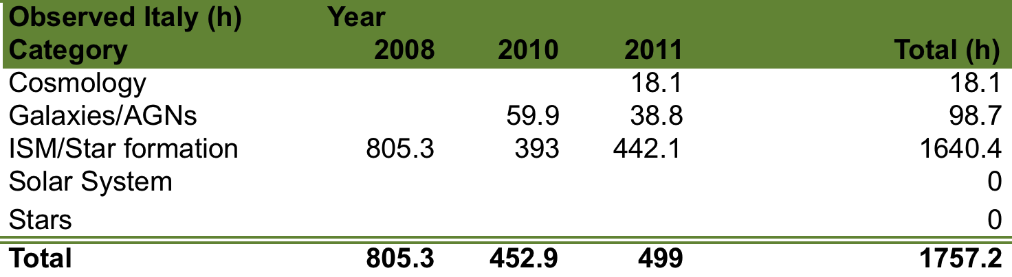

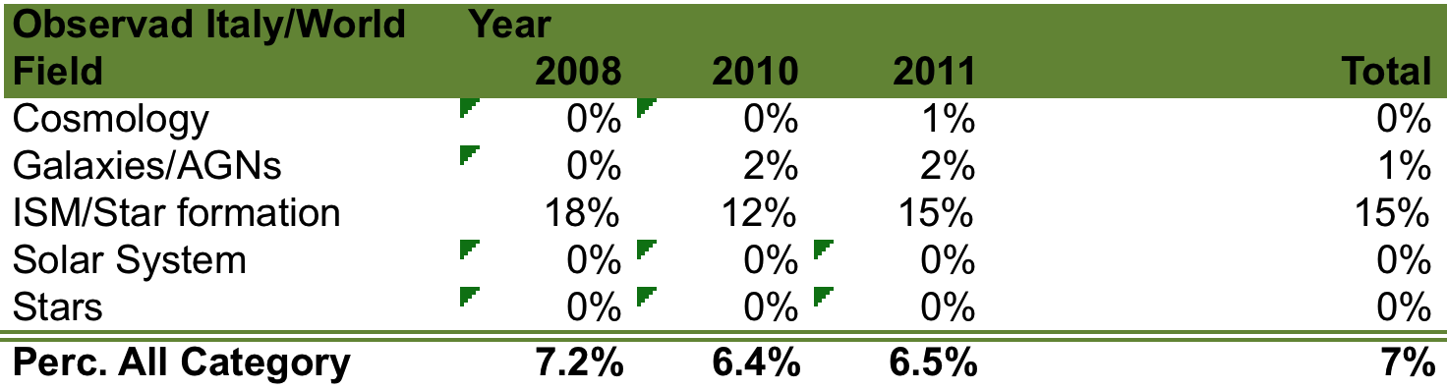

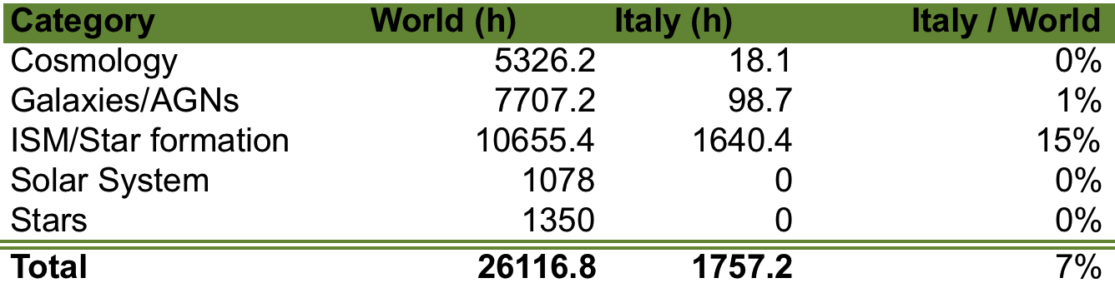

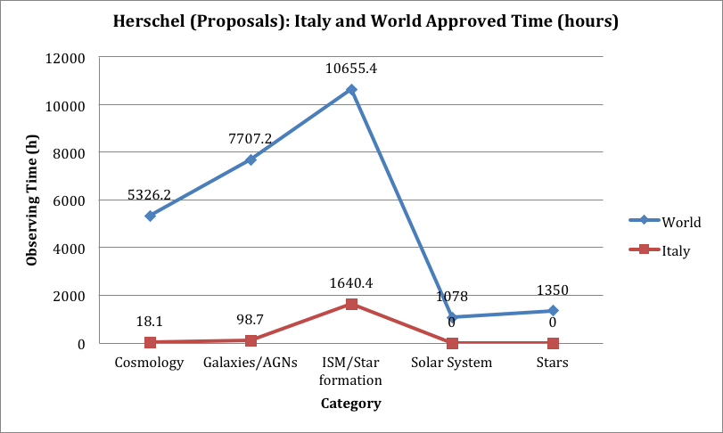

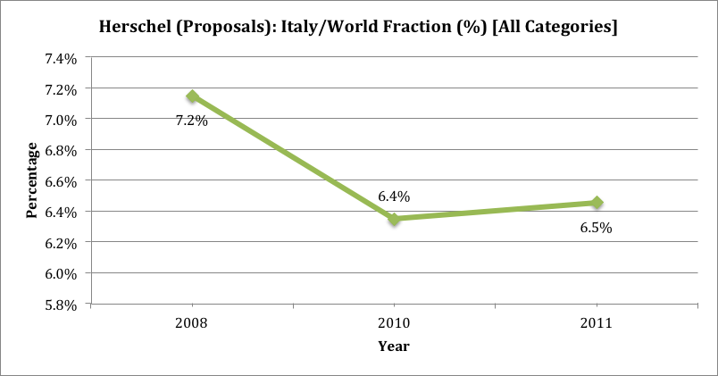

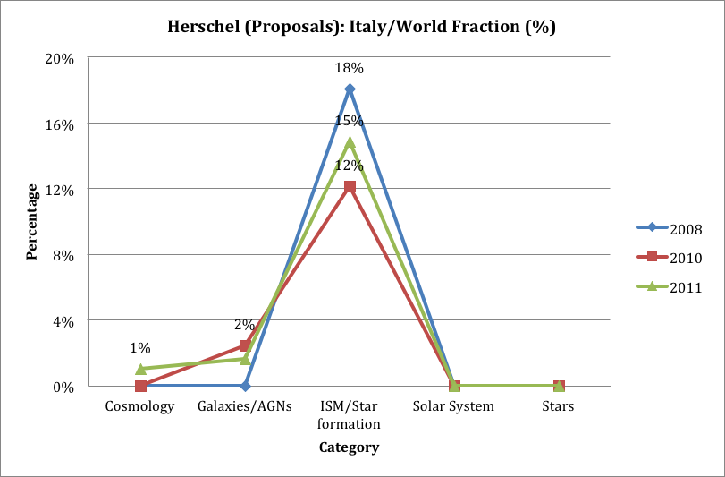

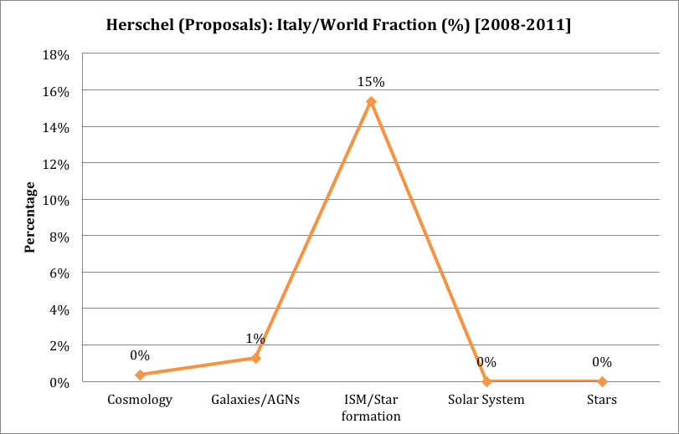

***2) REFEREED PAPERS (2008-2013):***

Origin of data:

* + - HERSCHEL SCIENCE CENTRE (ESA)

(herschel.esac.esa.int/hpt/publicationlist.do)

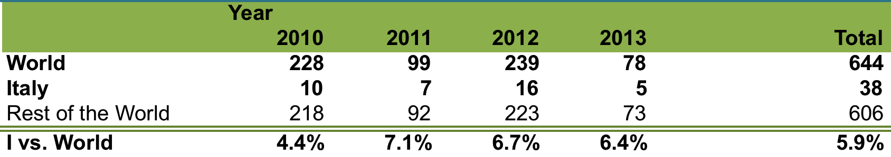

# Space facility 7 : HST

***Hubble Space Telescope***

Launch: 1990

The Hubble Space Telescope (HST) is a collaboration between the European Space Agency (ESA) and the National Aeronautics and Space Administration (NASA). HST is a 2.4-meter reflecting telescope currently equipped with the following instruments:

ACS: Advanced Camera for Surveys

COS: Cosmic Origins Spectrograph (4th generation instrument)

FGS: The Fine Guidance Sensors

NICMOS: Near Infrared Camera and Multi Object Spectrometer

STIS: Space Telescope Imaging Spectrograph

WFC3: Wide Field Camera 3 (4th generation instrument)

Status: ongoing

***1) ACCEPTED OBSERVING PROPOSALS (2008-2011):***

Origin of data:

* + - SPACE TELESCOPE SCIENCE INSTITUTE

(http://www.stsci.edu/hst/proposing/)

|  |  |
| --- | --- |
| **Categories** |  |
| AGN | Active Galactic Nuclei/Quasars |
| COS | Cosmology |
| CS | Cool Stars |
| EXO | Extra-Solar Planets |
| HS | Hot Stars |
| IEG | ISM in External Galaxies |
| ISM | ISM and Circumstellar Matter |
| QAL | Quasar Absorption Lines and IGM |
| RSP | Resolved Stellar Population |
| SF | Star Formation |
| SS | Solar System |
| USP | Unresolved Stellar Population and Galaxy Structure |

The following tables and figures show the number of the approved proposals.

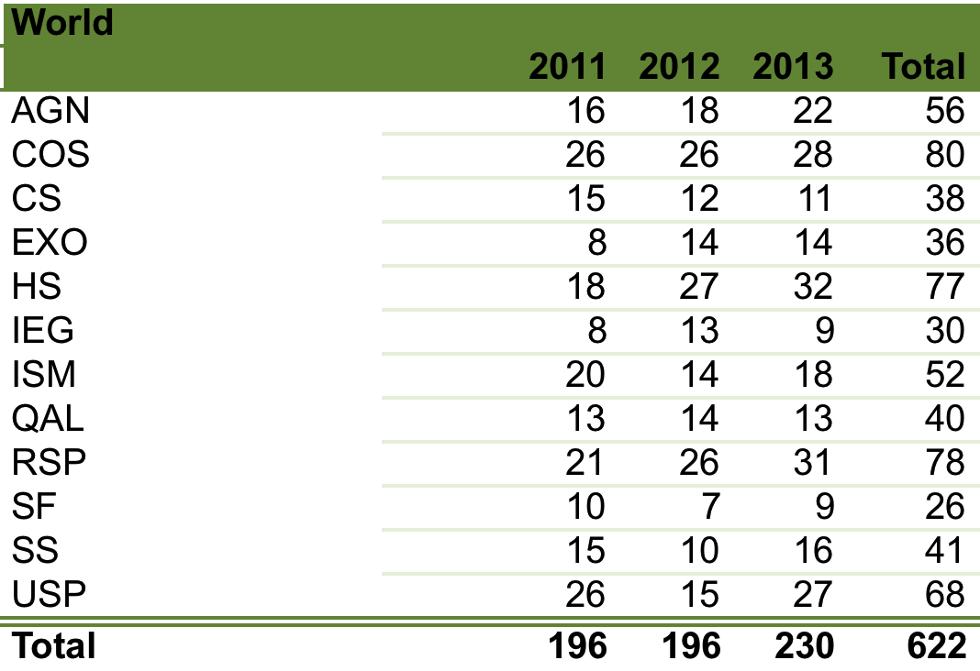

|  |  |  |  |  |
| --- | --- | --- | --- | --- |
| **Italy** |  |  |  |  |
|  | **2011** | **2012** | **2013** | **Total** |
| AGN |  |  |  | 0 |
| COS |  |  |  | 0 |
| CS |  |  |  | 0 |
| EXO |  |  |  | 0 |
| HS |  | 2 | 2 | 4 |
| IEG |  |  |  | 0 |
| ISM |  |  |  | 0 |
| QAL |  |  |  | 0 |
| RSP | 3 | 3 | 2 | 8 |
| SF |  |  |  | 0 |
| SS |  |  |  | 0 |
| USP |  |  | 1 | 1 |
| **Total** | **3** | **5** | **5** | **13** |

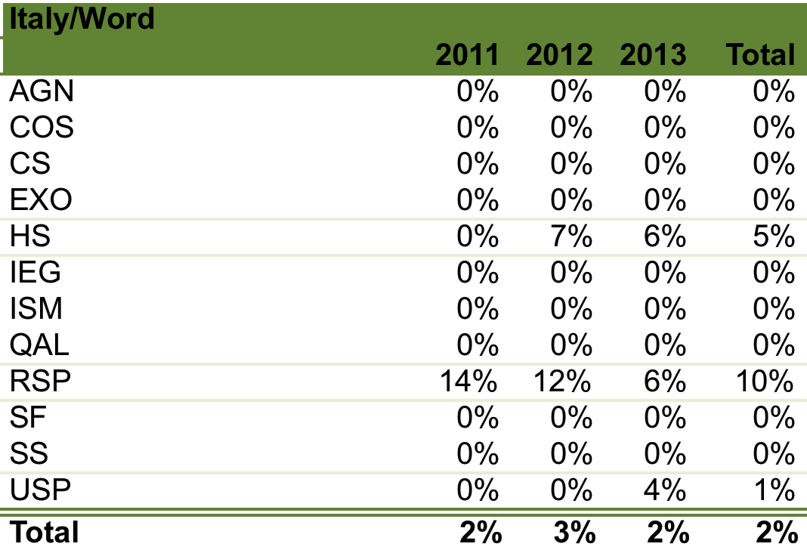

Due to the quite low number of the approved proposals, it is also shown the similar ratio for Uk, Germany and France.

***2) REFEREED PAPERS (2008-2013):***

Origin of data:

* + - SAO/NASA Astrophysics Data System (ADS)

(query: "Hubble" string in the abstract)

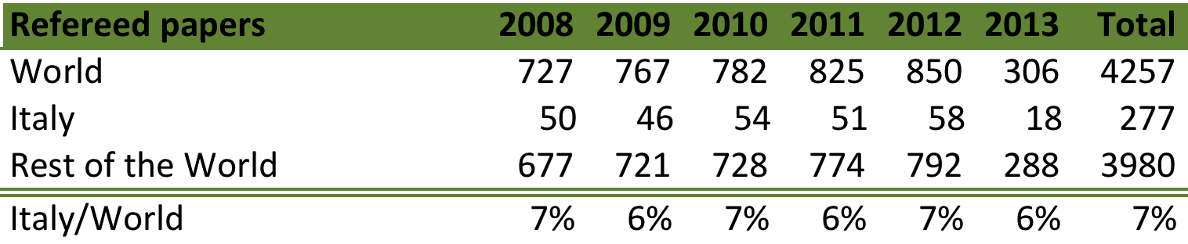

# Space facility 8 : CHANDRA

***CHANDRA Space Observatory***

Launch: 1999

The Chandra X-ray Observatory (CXO) is designed for high resolution (≤ 1/2 arcsec) X-ray imaging and spectroscopy. The High Resolution Mirror Assembly (HRMA) focuses X-rays onto one of two instruments, Advanced CCD Imaging Spectrometer (ACIS) or High Resolution Camera (HRC). The HRC energy range (0.06-10 keV) extends below that of ACIS, (0.08-10 keV) and the field-of-view are 31x31 arcmin (HRC) and 16x16 arcmin (ACIS). Two high-resolution spectrograph are also available i) the High Energy Transmission Grating (HETG) is optimized for high-resolution spectroscopy of bright sources over the energy band 0.4-10 keV. The Low Energy Transmission Grating (LETG) provides the highest spectral resolving power (E/ΔE > 1000) on Chandra at low energies (0.07 - 0.2 keV).

Status: ongoing

***1) ACCEPTED OBSERVING PROPOSALS (2009-2013):***

Origin of data:

* "CHANMASTER" DATABASE (NASA - HEASARC)

(http://heasarc.gsfc.nasa.gov/W3Browse/chandra/chanmaster.html)

* Chandra X-Ray Center (CXC)

(http://cxc.harvard.edu/target_lists/index.html)

|  |  |
| --- | --- |
| Categories: |  |
|  | Active galaxies and quasars |
|  | BH and NS binaries |
|  | ExtraGalactic diffuse emission and surveys |
|  | Galactic diffuse emission and surveys |
|  | Normal galaxies |
|  | SN, SNR and isolated NS |
|  | Solar System |
|  | Stars and WD |
|  | WD binaries and CV |
|  | Cluster of galaxies |

The following tables and figures show the data on the allocated observing time (ks).

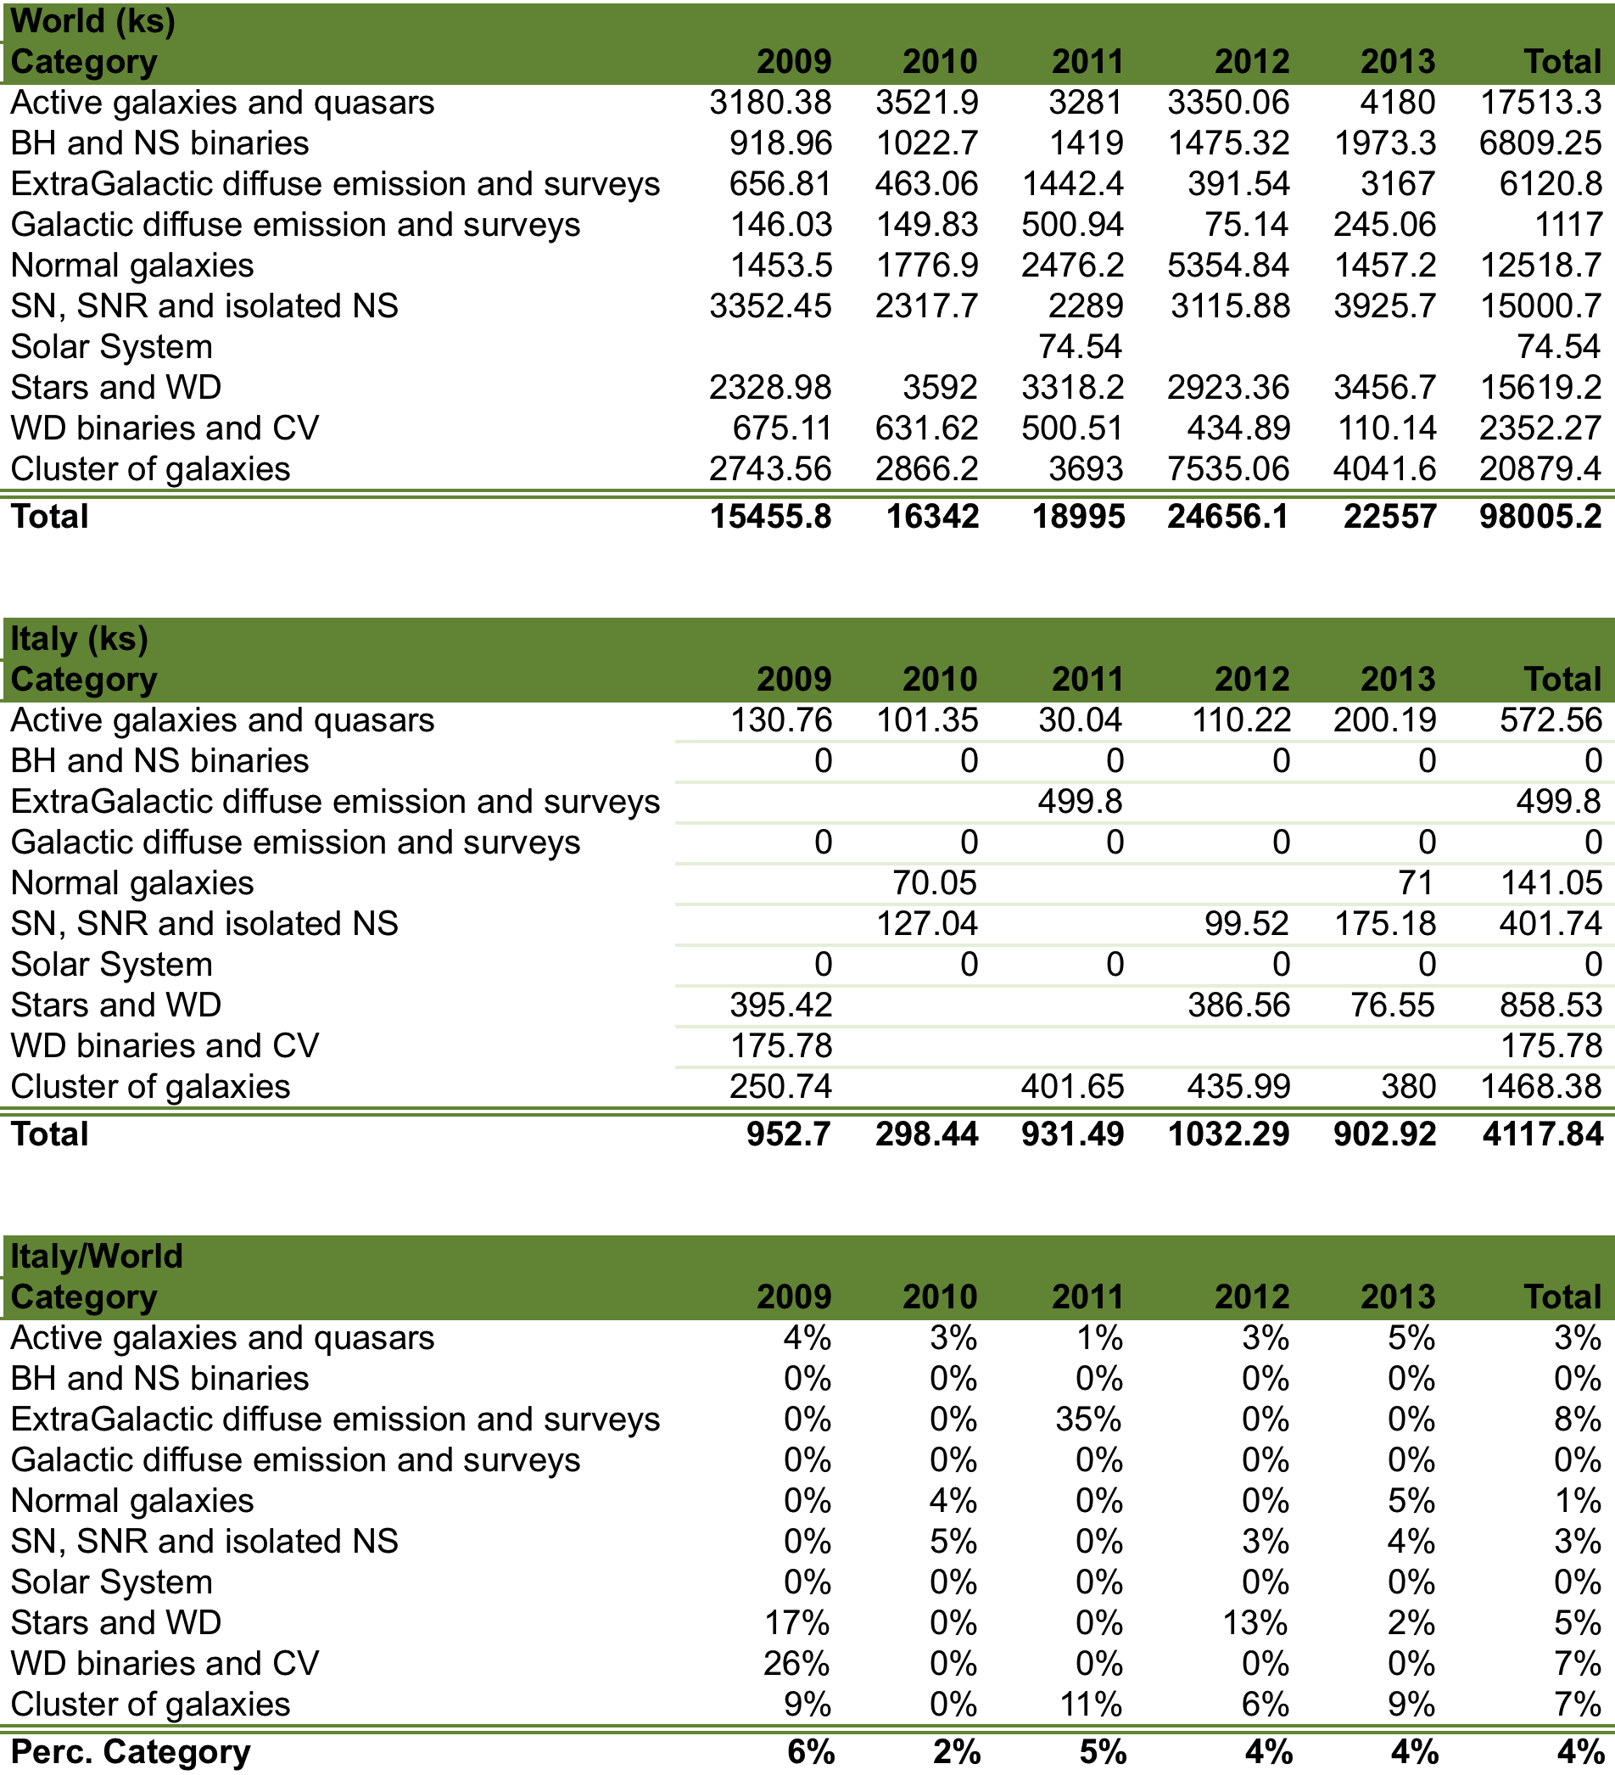

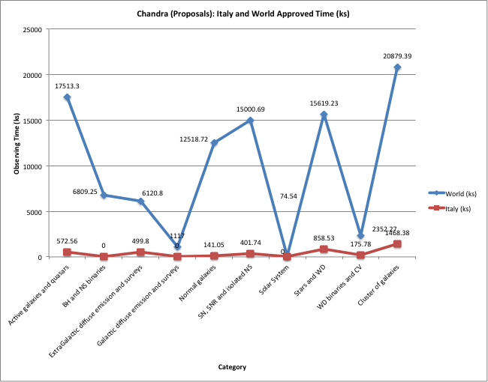

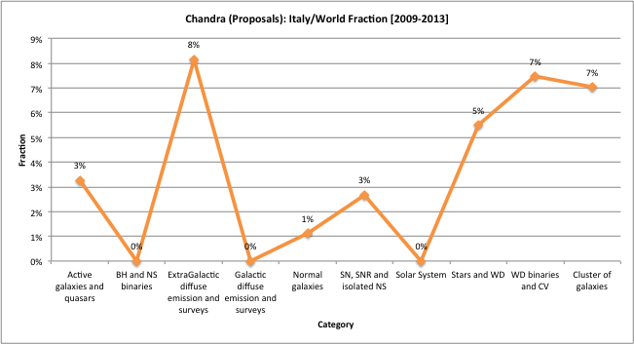

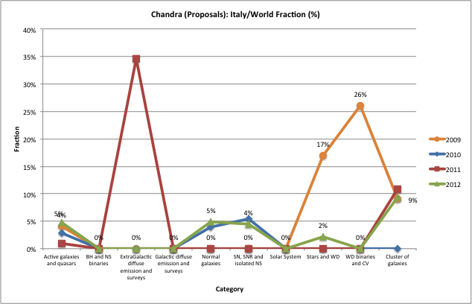

***2) REFEREED PAPERS (2008-2013):***

Origin of data:

* SAO/NASA Astrophysics Data System (ADS)

(query: "Chandra" string in the abstract)

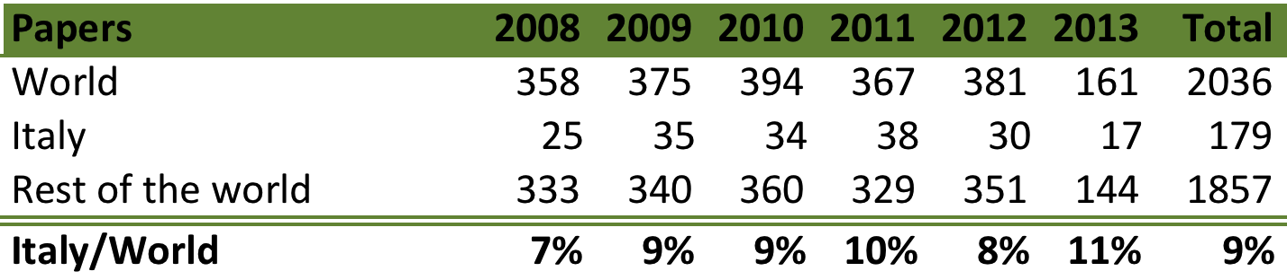

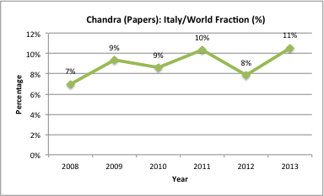

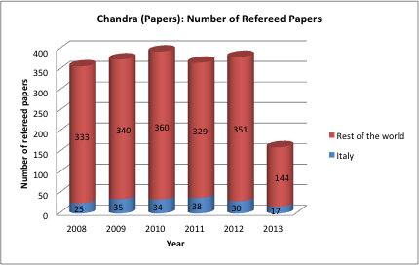

# Space Facility 9 : PLANCK

***Planck Telescope***

Launch: 2009

Planck's telescope is an off-axis tilted Gregorian design. The collected light focuses onto the two scientific instruments:

* LFI (Low Frequency Instrument), an array of radio receivers using high electron mobility transistor mixers;
* HFI (High Frequency Instrument), an array of microwave detectors using spider bolometers equipped with neutron transmutation doped germanium thermistors.

Planck provides a map of the Cosmic Microwave Background (CMB) field at all angular resolutions greater than 10 arc-minutes and with a temperature resolution of the order of one part in 106. The simultaneous mapping of the sky at a wide range of frequencies enables the separation of the Galactic and extragalactic foreground radiation from the primordial cosmological background signal.

Status: Turned off

The specific policy of this mission prevents statistics on the proposals. For what concerns the publications the "Italy"/"Rest of the World" classification was derived according to the following criteria:

* Public Planck Data (2a): affiliation of the first author of the work;
* Planck Collaboration Scientific Papers (2b): affiliation of the Planck Project Leader(s) of each work (Gianluca Polenta & Paolo Natoli, *private communication*);
* Planck Collaboration Technical Papers (2c): affiliation of the first author of the work.

We acknowledge Gianluca Polenta (ASDC) for his help.

#### 2a) REFEREED PAPERS MAKING USE OF PUBLIC PLANCK DATA (produced by scientists not representing the Planck Collaboration):

Origin of data:

* ESA Planck Mission Site:

(http://www.sciops.esa.int/index.php?project=PLANCK&page=Planck_Published_Papers)

#### 2b) PLANCK "EARLY", "INTERMEDIATE" AND "2013" RESULTS REFEREED PAPERS (produced by scientists belonging to the Planck Collaboration):

Origin of data:

* ESA Planck Mission Site:

(http://www.sciops.esa.int/index.php?project=PLANCK&page=Planck_Published_Papers)

#### 2c) PLANCK "PRE-LAUNCH" AND "TECHNICAL" REFEREED PAPERS (produced by scientists belonging to the Planck Collaboration):

Origin of data:

* ESA Planck Mission Site:

(http://www.sciops.esa.int/index.php?project=PLANCK&page=Planck_Published_Papers)

1. **Ground Facilities**

# Ground facility 1 : TNG

***Telescopio Nazionale Galileo***

TNG is 3.58m Alt-Az telescope equipped with an active optics system. Its 2 Nasmyth foci host 3 instruments: DOLORES (Device Optimized for the LOw RESolution), is an imager (FoV=8.6x8.6 arcmin, scale=0.252 arcsec/px) + low resolution spectrograph (R=500-6000); NICS (Near Infrared Camera Spectrometer) is the infrared camera/spectrometer (es.: FoV=4.2x4.2 arcmin, scale=0.25 arcsec/px); HARPS-N (High Accuracy Radial velocity Planet Searcher in North hemisphere) is an echelle spectrograph working in the range 383-693 nm and spectral resolution R=115000.

http://www.tng.iac.es/

Status: ongoing

***1) ACCEPTED OBSERVING PROPOSALS (2009-2013):***

Origin of data:

E. Molinari (TNG- Director)

The data and figures are extracted by a recent presentation of E. Molinari.

The number of accepted proposals with Italian P.I. is of the order of 75-80% with respect to all accepted proposals.

|  |  |  |
| --- | --- | --- |
| Categories: |  | |
| A | | Cosmology |
| B | | Galaxies and galactic nuclei |
| C | | Interstellar medium, star formation and planetary systems |
| D | | Stellar evolution |

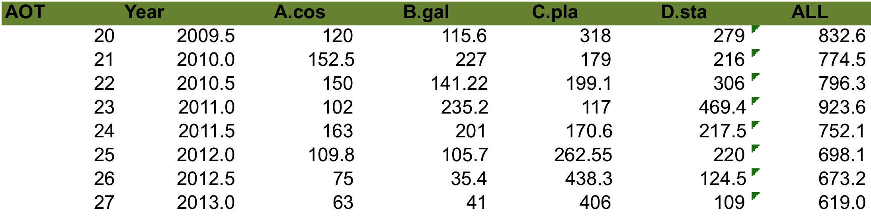

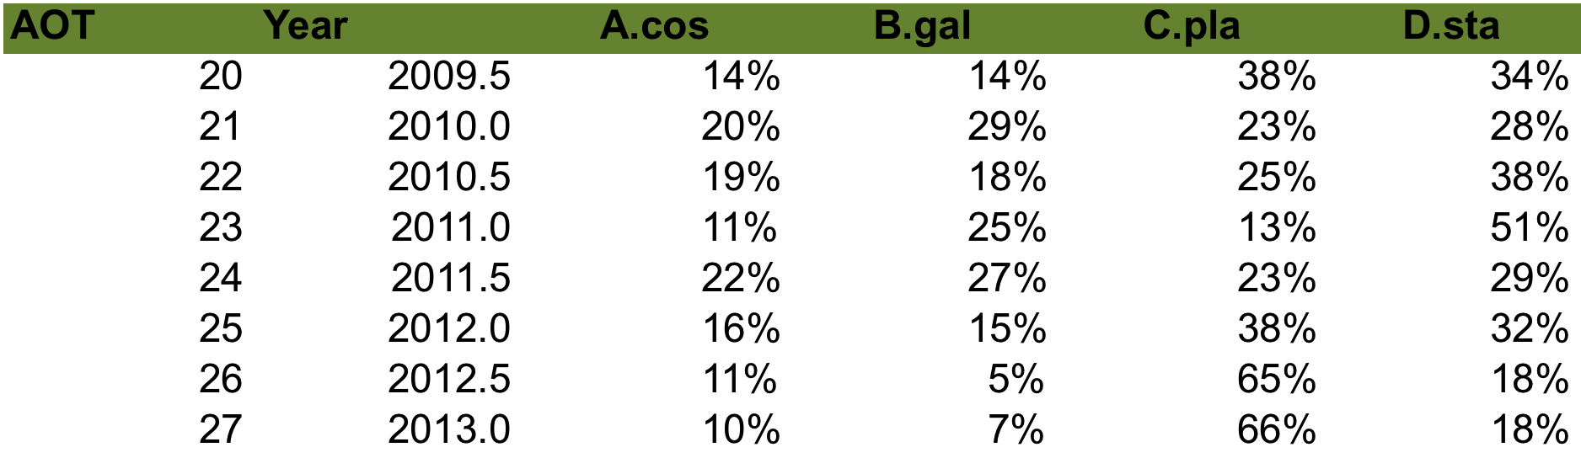

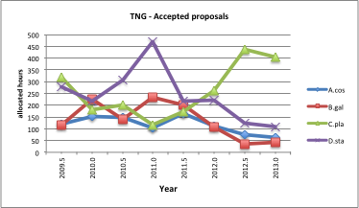

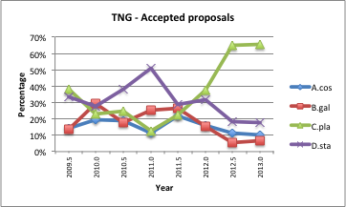

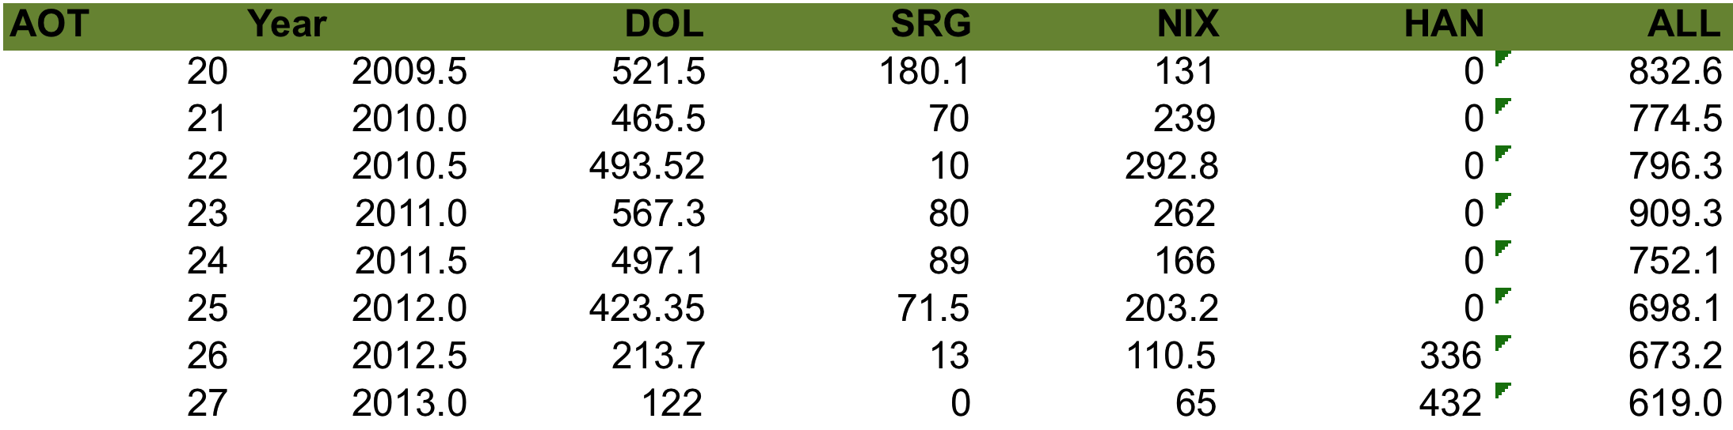

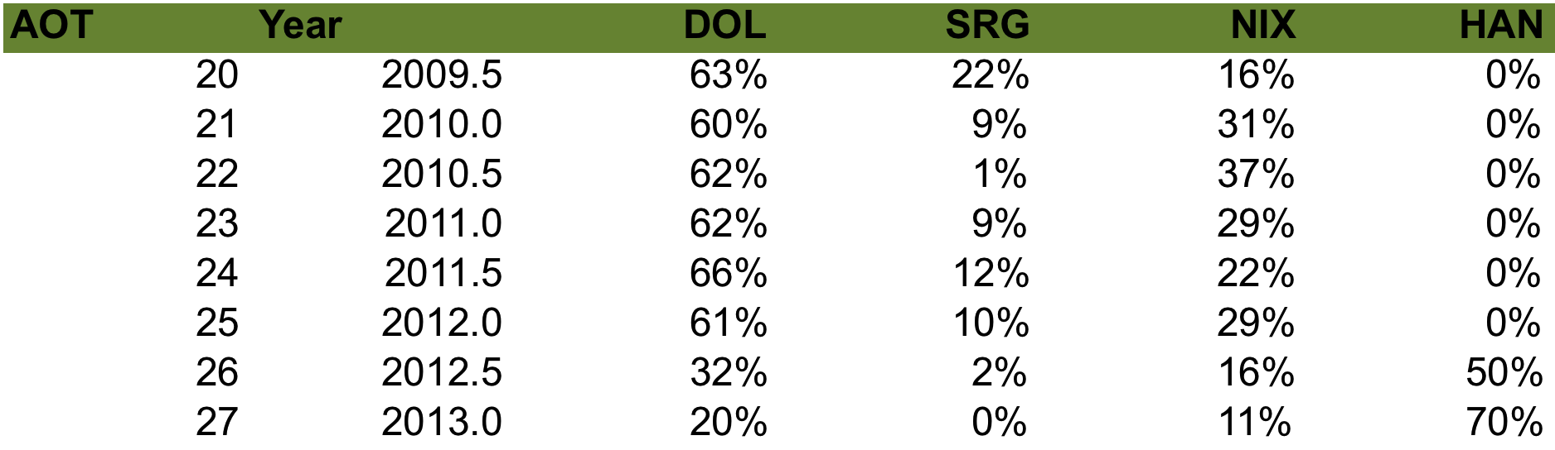

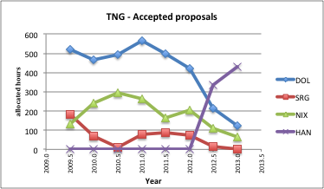

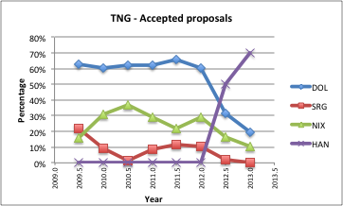

***2) REFEREED PAPERS (2008-2012):***

Origin of data:

E. Molinari (TNG- Director)

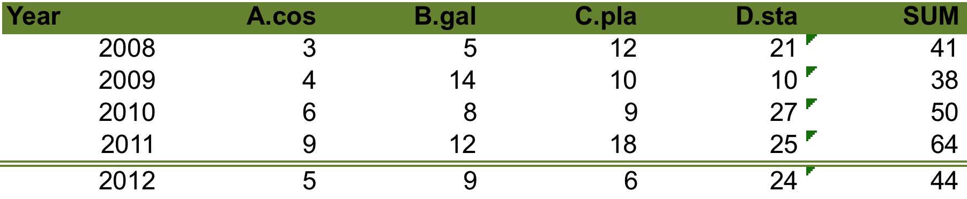



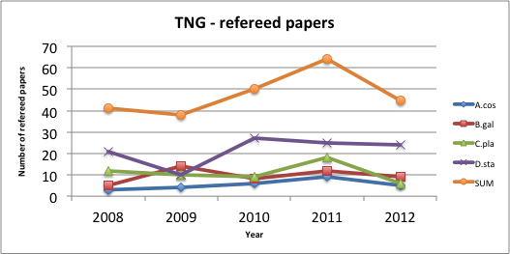

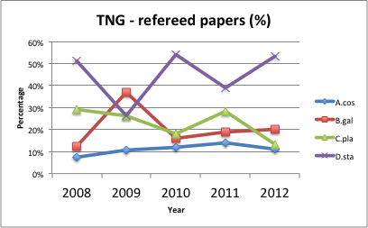

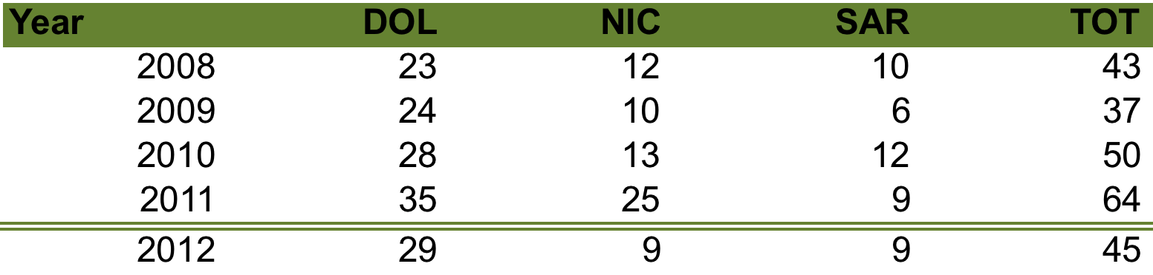

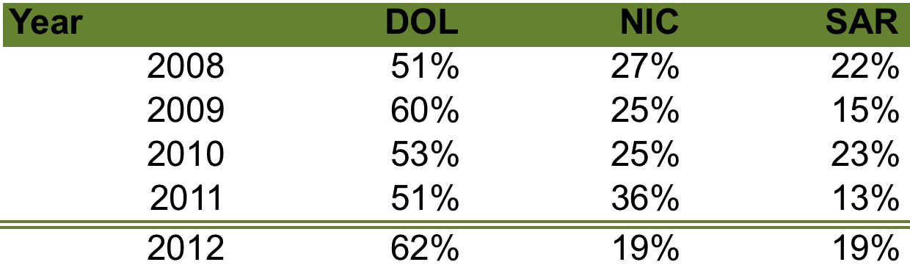

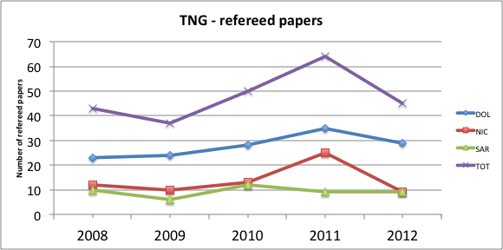

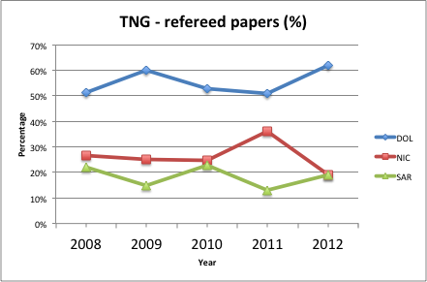

# Ground facility 2 : LBT

***Large Binocular Telescope***

The Large Binocular Telescope is a facility composed of two mirrors (8.4m) operating to allow the contemporary observation of the same field of view. Italy (25%), Germany and USA are the partners of this collaboration. The available instruments are: LBC (Large Binocular Cameras)

http://lbt.oa-roma.inaf.it/

Status: ongoing

***1) ACCEPTED OBSERVING PROPOSALS (2009-2013):***

Origin of data:

A. Fontana (LBT- Italian Coordinator)

|  |  |  |
| --- | --- | --- |
| Categories: |  | |
| A | | Cosmology |
| B | | Galaxies and galactic nuclei |
| C | | Interstellar medium, star formation and planetary systems |
| D | | Stellar evolution |

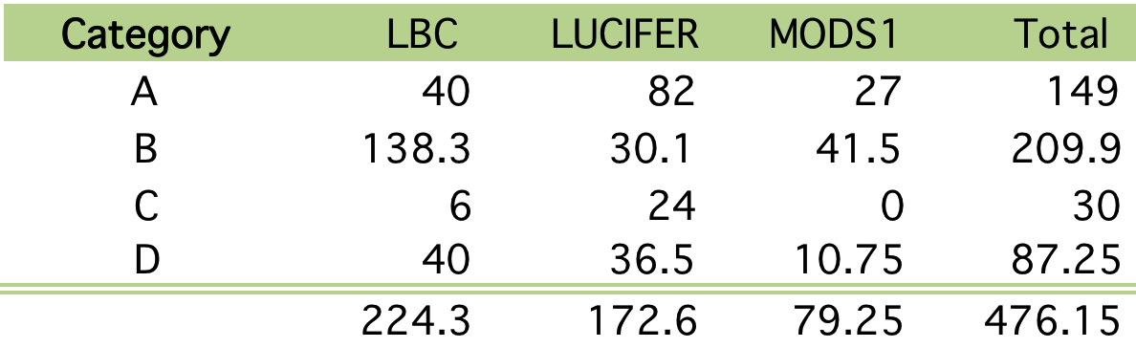

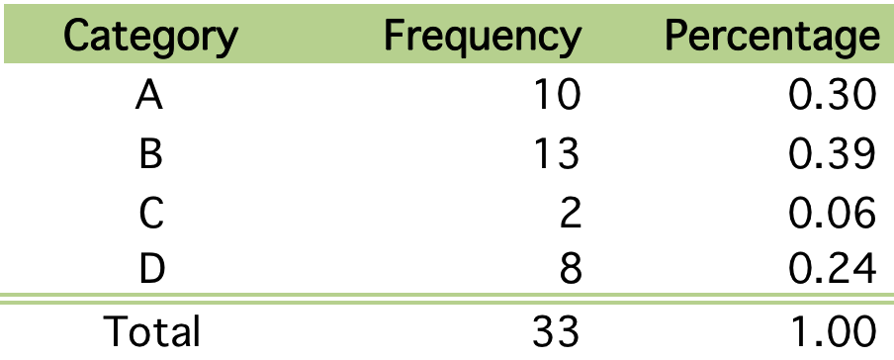

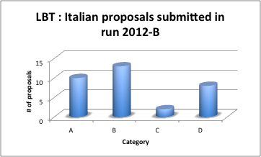

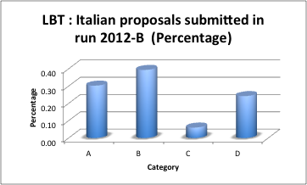

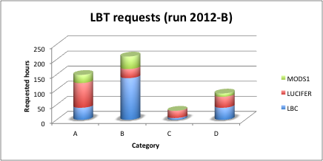

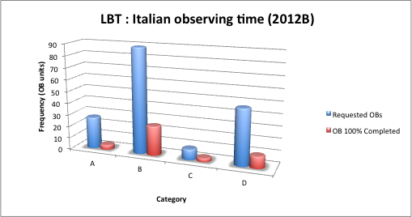

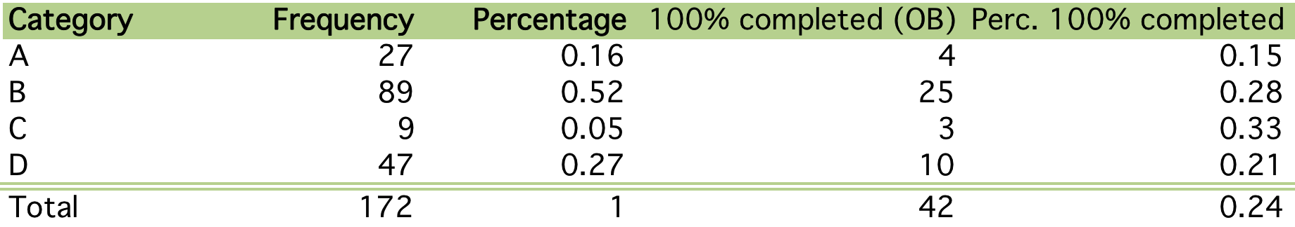

***2) REFEREED PAPERS (2007-2013):***

Origin of data:

<http://lbt.oa-roma.inaf.it/science.html>

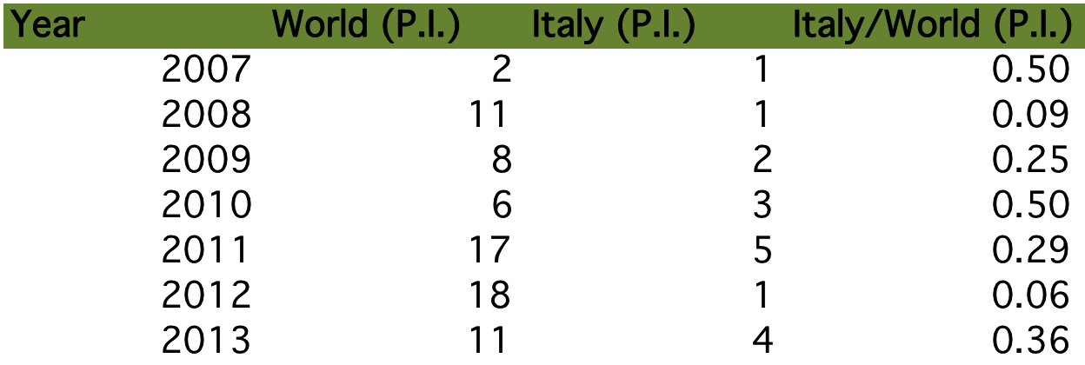

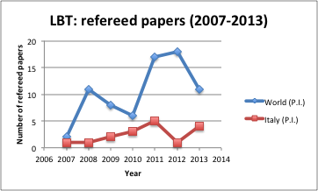

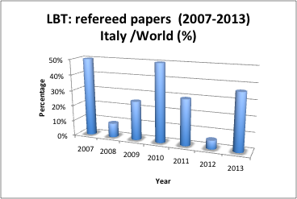

# Ground facility 3 : Radio Telescopes

***Radio Telescopes***

The radio telescope facilities considered are the two 32-m single dish antennas located in Medicina and Noto (Sicily). The SRT (Sardinia Radio Telescope, 64-m antenna) is under construction in Sardinia and the "Northern Cross Radiotelescope" is under a substantial upgrading. Thus these two facilities are not considered here.

Status: ongoing

***1) ACCEPTED OBSERVING PROPOSALS (2012-2013):***

Origin of data:

The data concerning the accepted observing proposals are kindly provided by C. Stanghellini (INAF-IRA). It should be recalled that the “Single dish” data could suffer of a bias due to the unavailability of the highly requested receiver in the K band (moved to SRT).

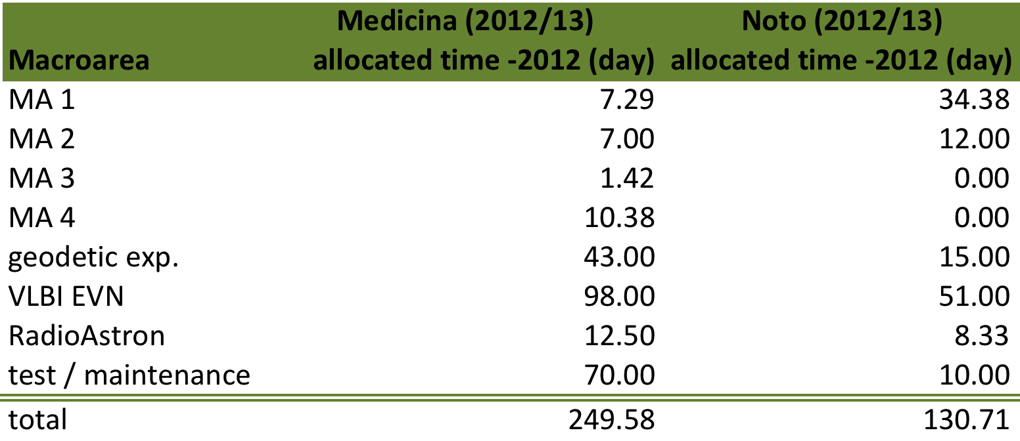

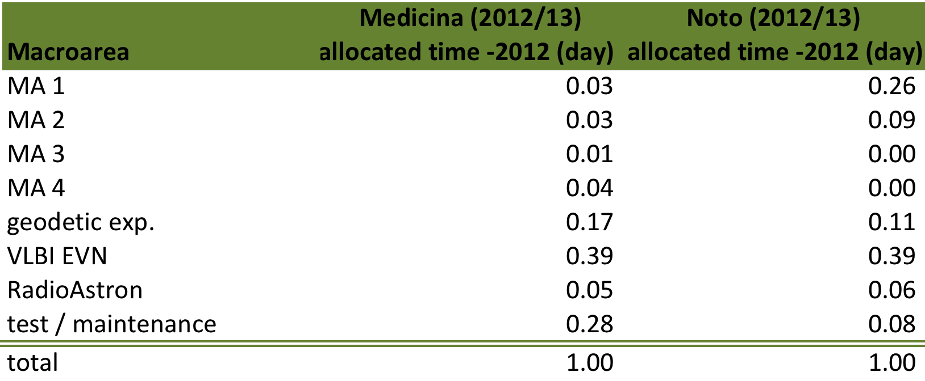

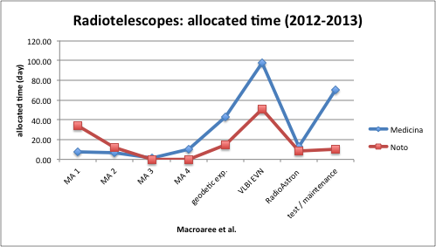

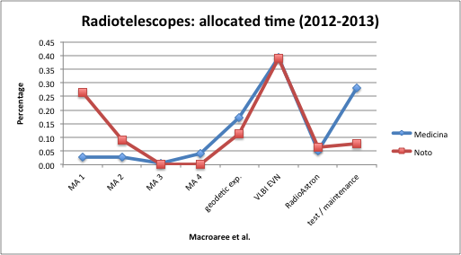

***2) REFEREED PAPERS (2008-2012):***

Origin of data:

Single dish : <http://www.ira.inaf.it/~brand/medicina-pubs.html>

VLBI : [http://www.ira.inaf.it/%7Emgirolet/pubs/vlbi.html](http://www.ira.inaf.it/~mgirolet/pubs/vlbi.html)

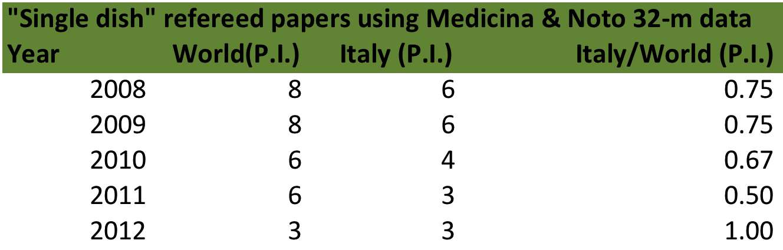

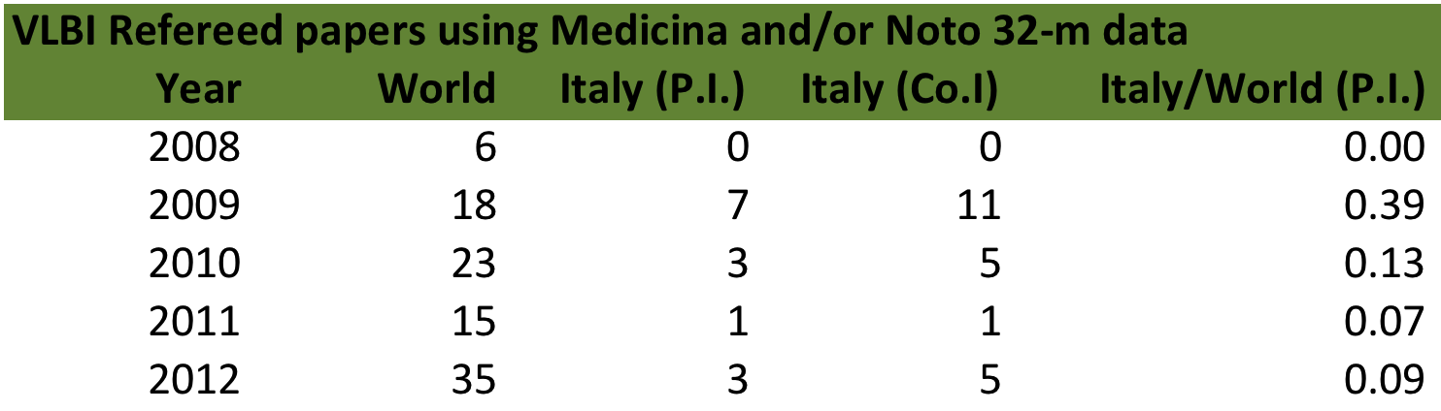

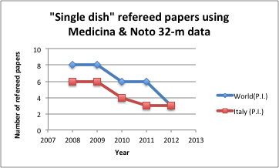

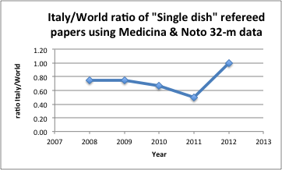

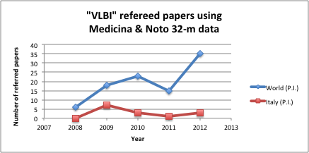

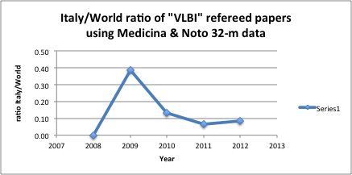

# Ground facility 4 : ESO Telescopes

***European Southern Observatory***

The ESO ground facilities widely contribute to the success of the Italian community in producing high-level results in several astronomical fields. Thus, a short non-exhaustive view on the use of ESO telescope and instruments by Italian researchers is presented.

Information on ESO telescopes and instruments can be found here: <http://www.eso.org/sci/facilities.html>

Status: ongoing

***1) ACCEPTED OBSERVING PROPOSALS (2012-2013):***

Origin of data:

F. Patat (ESO, Observing Programmes Office)

A description...

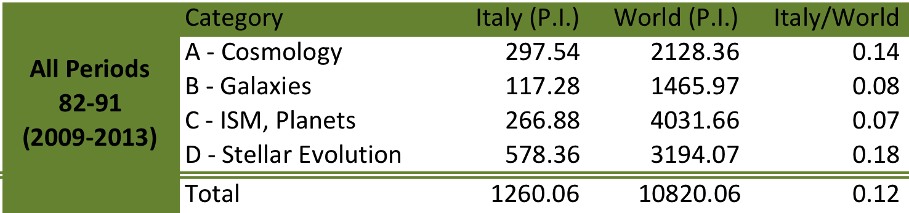

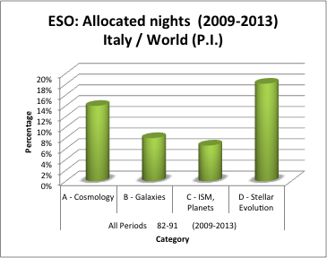

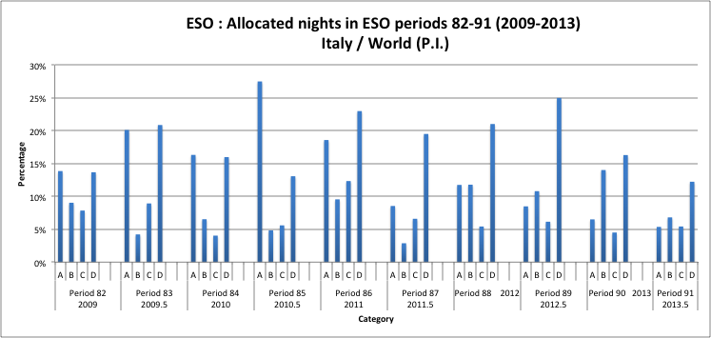

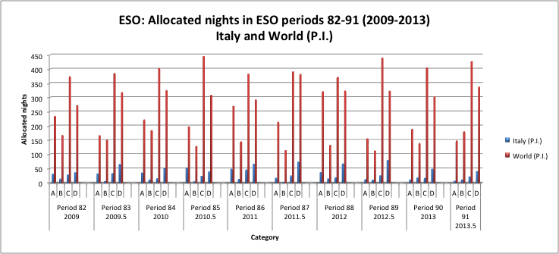

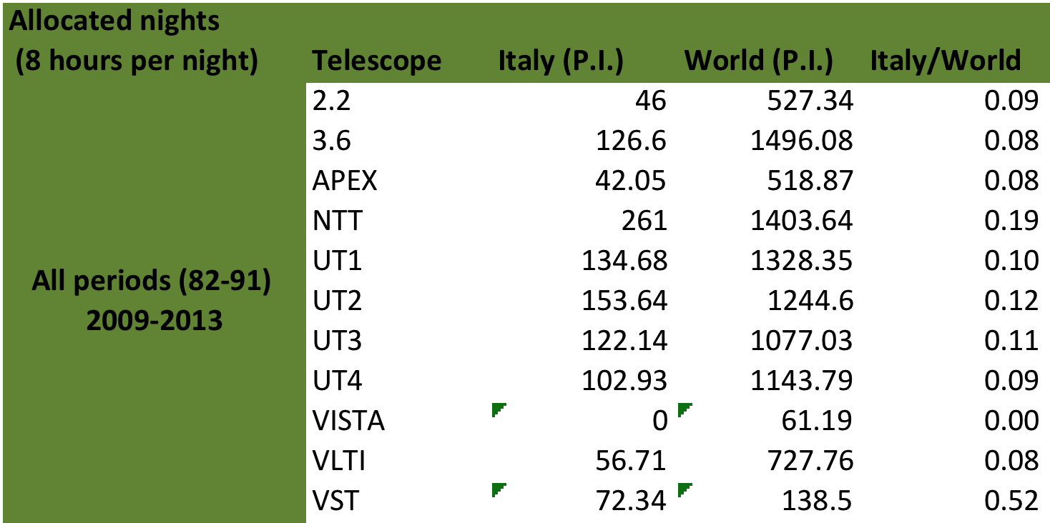

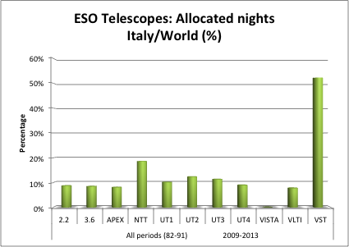

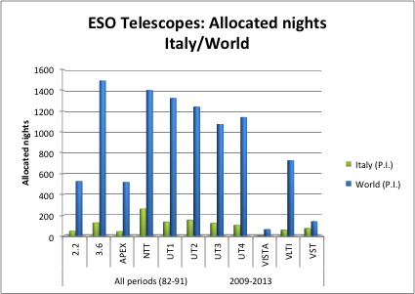

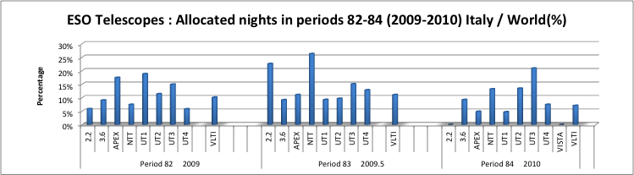

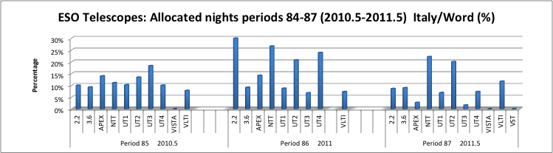

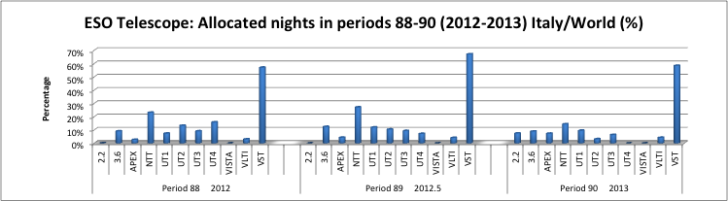

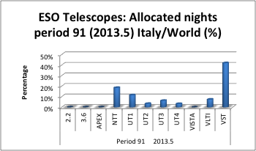

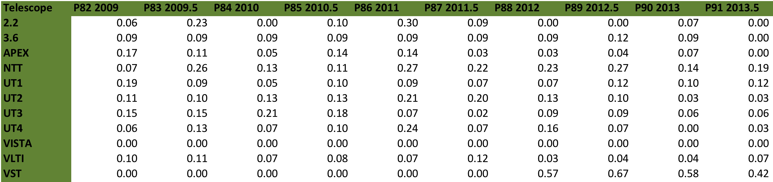

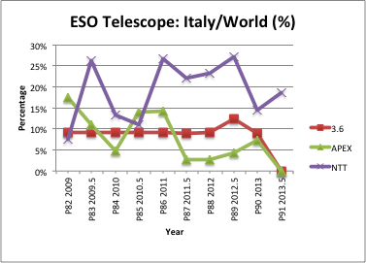

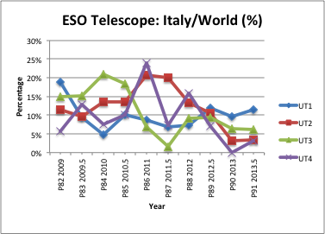

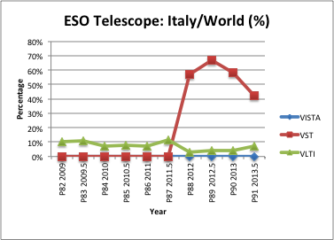

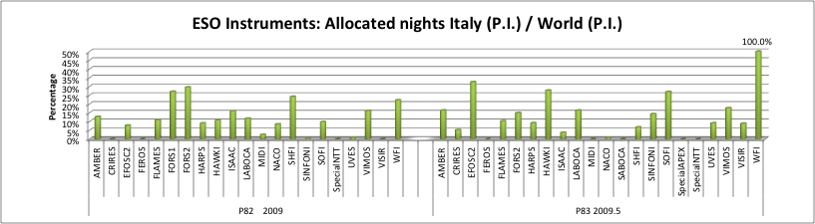

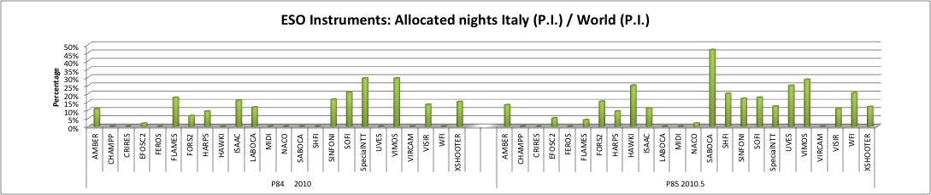

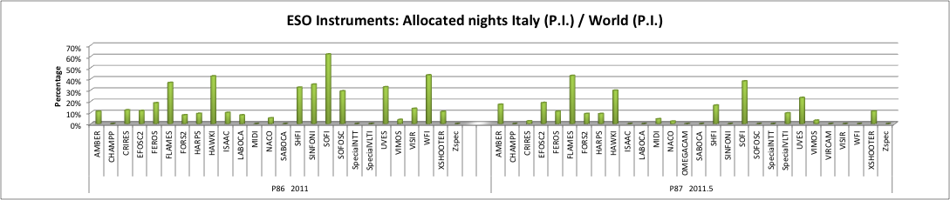

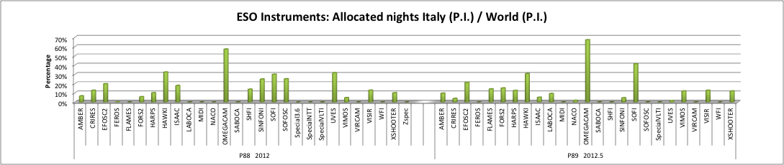

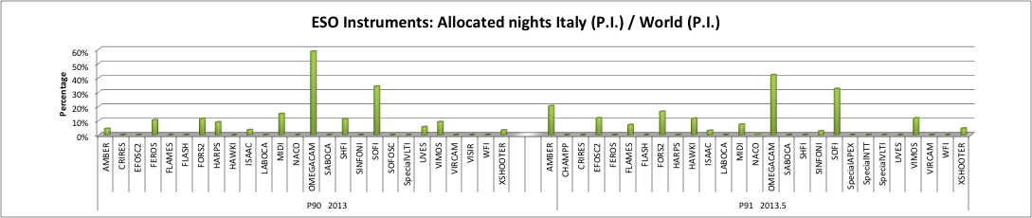

***2) REFEREED PAPERS (2008-2013):***

Origin of data:

* + - <http://telbib.eso.org/>

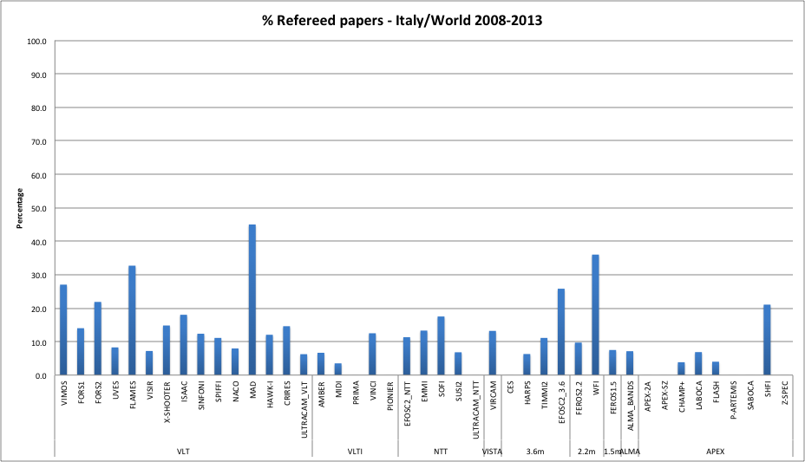

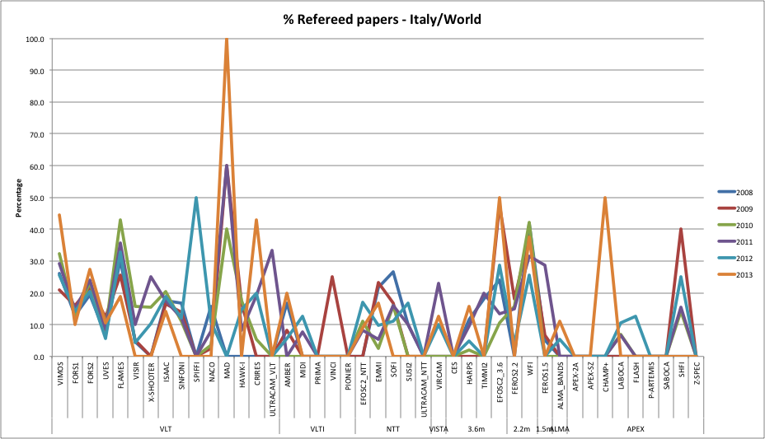

1. **Concluding Remarks**

The observational facilities considered in the present report cover a wide range of requirements in many different astrophysical fields. For this reason the instruments, the management, the call for proposal policy, the observational strategies and the average time needed for publishing the observational results can be extremely different between one facility and another.

Thus, any comparison between these observational facilities requires specific care and caution to avoid over-interpretation and misleading conclusions.

Nevertheless, one may want to evaluate and quantify the effectiveness of the Italian astrophysicists in making a productive use of these facilities in comparison with the world international astronomical community.

Keeping in mind the above warnings, a tentative comparison can be done by defining a handful of indicators for each single observational facility to monitor: i) the number of papers published by using each observational facility and the papers whose the first author is Italian, and ii) the quantity of observational time allocated per year and the fraction allocated to Italian P.I.s.

All these quantities are averaged – when possible – over a period covering the last 4-5 years.

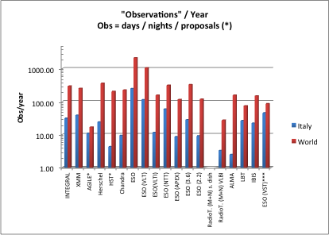

Note that VST is included in the plot since the data on the allocated observational time are available (ESO) even if they refer to the last year and most of the Italian time is GTO. Nevertheless, no search on refereed papers has been performed due to the short time since the facility has become available for science observations.

The IBIS facility is a special interferometer built in Italy (OA-Arcetri and Tor Vergata) and it is presently used for solar imaging spectroscopy & polarimetry with spectral resolution R~200000. It is operating at the Dunn Solar Telescope (DST) of the National Solar Observatory (USA). Being a NSF facility, it is fully open to accept international proposals. It has been included to have a small insight in the field of the solar observations.

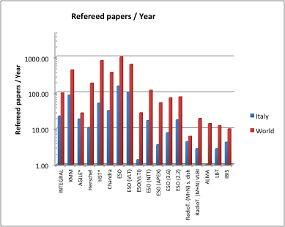

The relative ratios of these indicators for Italy and World provide a parameter which measures a sort of “efficiency” of using *each single facility* by the Italian and by the World astronomical communities.

In the following, relevant ratios of the quoted indicators are showed.

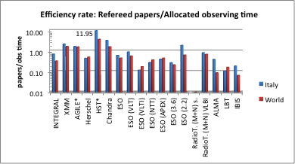

An effective way to synthesize the data is to plot the ratio between the Italian efficiency and the World efficiency. In particular, when this ratio for each single facility is larger than 1, it simply means that the Italy performance is better than the average performance of the World community operating with the same facility.

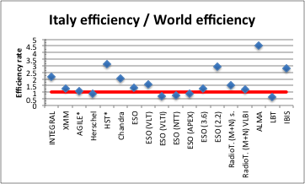

The results show a clear and significant excellence of Italian astrophysicist in leading successful research when compared to the overall international use of the examined observational facilities.

At least, two aspects can be enlightened:

first, the Italian astrophysicists are more efficient in obtaining and publishing scientific results from their observational time nearly for all the space and ground facilities analyzed in the present report.

Second, the Italian astronomical community appears flexible and ready to fully exploit the wide range of technical and scientific capabilities provided by the ground and space observational facilities.